Modeling with Density Performance Task – Teacher Support

Common Core State Standards:
- HSG-MG.A.2 – Apply concepts of density based on area and volume in modeling situations (e.g., persons per square mile, BTUs per cubic foot).
- HSA.CED.A.4 - Rearrange formulas to highlight a quantity of interest, using the same reasoning as in solving equations. For example, rearrange Ohm's law V = IR to highlight resistance R.

Core Skills Needed:
- Rearranging literal equations
- Solving multistep equations
- Calculating volume of 3D figures

Solutions:

The goal of this task is to provide a introduction to the sometimes subtle use of density and units related to density, in a simple and fun context with minimal geometric complexity.
This task provides an opportunity for working with MP4, Modeling with Mathematics. Most people watch this video clip without surprise or questioning. It is only when we begin to study what is happening through the lens of mathematics that something appears to be amiss. This activity is open ended and there are many pathways to a solution. Provided are two solutions.
Solution 1: Using the meaning of density
- The given density of gold, 20 g/cm³, is 8 times the given density of sand, 2.5 g/cm³. So we would need an amount of sand nearly 8 times the volume of the statue in order to have the same mass as the gold statue. Looking at the video, this is clearly not the case. If anything, it appears that the volume of sand is less than the volume of the statue. So unless the statue is hollow, the sand will weigh far less than the golden statue and Indiana Jones is doomed to failure.

- To find the mass of the statue, we can multiply its volume by the density of gold:

1000 cm × 20 g/cm³ = 2000g

This is 20 kg. Since a kilogram is about 2.2 pounds this is more than 40 pounds! Certainly the way the statue is handled is not consistent with this kind of weight.
Solution 2: Estimating the volume and mass of objects
We can find an approximate estimate for the volume of the sand and statue and then use the given density to obtain the masses. The bag of sand appears to fit nicely in Indiana Jones' hand. When he places the bag down on the podium it is quite flat, maybe 5 centimeters high. If we imagine the bag of sand in the shape of a rectangular prism, 20 centimeters by 20 centimeters would be a reasonable estimate for the base. With these numbers we find a volume of about

20 cm x 20 cm x 5 cm = 2000 cm³

Next for the statue. We can also try to approximate this with a rectangular prism. Its height also appears to be comparable to the length of Indiana Jones' hands and we used 20 centimeters for this when we estimated the volume of the bag of sand. It is not as wide or deep as it is high. It looks to be about 7 centimeters high and about 10 centimeters deep. This gives a total volume of
20 cm x 7 cm x 10 cm = 1400 cm³
Now to find the mass, we can use the given information for the density of sand and for gold. First for the sand, 2000 cubic centimeters will have a mass of about
2000 cm³ x 2.5 g/cm³ = 5000 g
This is 5 kilograms or a little more than 10 pounds. Next for the statue,
1400 cm³ x 20 g/cm³ = 28,000 g
This is 28 kilograms or about 60 pounds. These two values are not close to one another and so, based on these estimates, it is extremely unlikely that the sand and the statue have the same mass.
While not exact, our estimates of the volume are close to one another and this is reasonable looking at the video: it is hard to tell whether or not the sand or the statue occupies more space. In fact, in the video the statue looks like it might take up more space than the sand. Given our calculations above, this makes it essentially impossible that the two have the same mass.

Solutions to TASC Problems:
1) D
2) B
3) 267.4 cm³
4) 7.96 cm
5) C
Math Performance Task: Modeling with Density
Indiana Jones and the Golden Skull

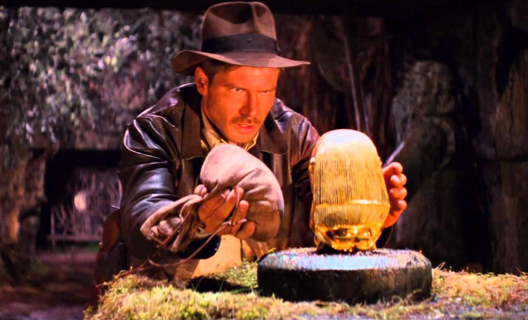
The following clip shows the famous opening scene of the movie Raiders of the Lost Arc. At the beginning of the clip, Indiana Jones is replacing the golden statue with a bag of sand:

https://youtu.be/dJ920fat50M
Or search for “Indiana Jones and the golden skull video”

The platform on which the statue is placed is designed to detect the mass of the statue so if the bag of sand has a different mass than the statue then a mechanism triggers the spectacular destruction of the cave.
- The density of gold is about 20 g/cm³ (at room temperature at sea level). The density of sand can vary but a good estimate is 2.5 g/cm³. Assuming the statue is solid gold, can the bag of sand and the gold statue have the same mass? Explain.

- Assuming the statue is about 1400 cm³ in volume, what would its mass be if it were solid gold? Is this consistent with the way the statue is handled and tossed around in the video clip?

Modeling with Density TASC Level Problems
1) A study is done on a park having an area of 325 acres and is found to have 85,230 trees. About how many trees per acre does the park have?  - .004 trees/acre  - 2622 trees/acre  - 426 trees/acre  - 262 trees/acre  2) A solid cylinder has a radius of 2 cm and a height of 7 cm. It has a density of 3.1 g/cm³. What is the mass of the cylinder (use π = 3.14)?  A. 12.1 g  B. 272.6 g  C. 87.96 g  D. 28.4 g  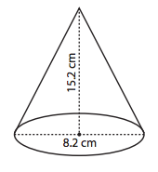  3. Calculate the volume of this cone. Round your answer to nearest tenth (use π = 3.14):  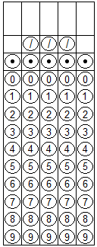 | 4) Find the height of a cylinder with a volume of 100 cm³ and a radius of 2 cm. Round your answer to nearest hundredth (use π = 3.14):  5) A hot air balloon holds 74,000 cubic meters of helium, a very noble gas with the density of 0.1785 kilograms per cubic meter. How many kilograms of helium does the balloon contain?  A. 740 kg  B. 6,529 kg  C. 13,209 kg  D. 414,565 kg

