Name: _____________

TASC Math – Practice Readiness Test (V1)

**Part I – Calculator Use Allowed**

1. Given the equation:

What is the value of *x* that will make the equation true?

**A.** 2

**B.** 10

**C.** 20

**D.** 60

1. Which of the following is equivalent to the equation ?



6. Which expression below is equivalent to ?

9. Given the function , the value of would be:
   1. -113
   2. -68
   3. 68
   4. 22
10. What is the solution to the system of equations below?
11. *x* = 4, *y* = –7
12. *x* = –4, *y* = –7
13. *x* = 4, *y* = 7
14. *x* = –4, *y* = 7
15. For what value of *x* is undefined?
16. 2
17. –2
18. -9
19. 9
20. Solve for *x*: 
    1. 3
    2. 4
    3. 5
    4. 6
21. The population of a group of rabbits can be modeled by the function , where *R*(*t*) is the population and *t* is the time in weeks.

What is the percent change in the population from one week to the next, and does this represent exponential growth or decay?

1. 12%; exponential decay
2. 12%; exponential growth
3. 112%; exponential decay
4. 112%; exponential growth
5. Fred, *F*, can do 24 more pushups than Tye, T. Together they did a total of 73 pushups.

Which system of equations can be used to find how many pushups they each did?

1. *F* + 24 = *T*

*F* + *T* = 73

1. *T* + 24 = *F*

*F* + *T* = 73

1. *F* + 24 = *T*

*F* – *T* = 73

1. *T* + 24 = *F*

*F* – *T* = 73

1. In Brooklyn 2.5 million people live in 97 square miles. What is the approximate population density per square mile of Brooklyn?
2. 26 people per square mile
3. 243 people per square mile
4. 26,000 people per square mile
5. 39,000 people per square mile
6. The longest side of a right triangle is 34 inches. One of the legs of the right triangle measures 30 inches. What it the length of the other leg?
7. 16 in.
8. 64 in.
9. 4 in.
10. 15 in.
11. Find the perimeter of *ABC*.

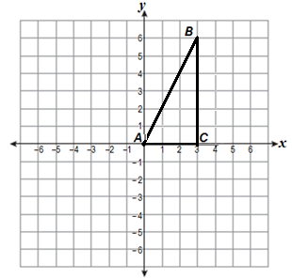

1. 15
2. 
3. 
4. 
5. Find the volume of the figure below.

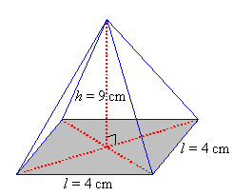

1. 36 cm3
2. cm3
3. cm3
4. cm3

z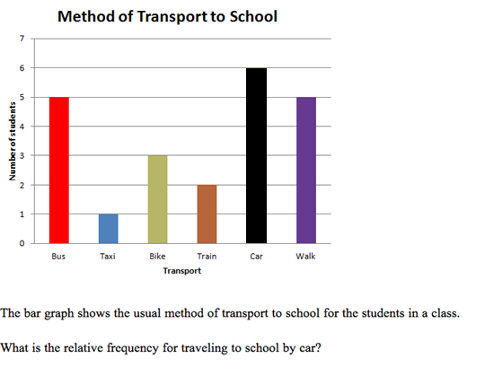

1. 0.375
2. 0.6
3. 6
4. Which names the function for the arithmetic sequence below?

11, 8, 5, 2, . . .

1. A circle has a radius of 4 cm. Find the length of an arc subtended by a central angle of 150**°.**
2. 600
3. **.** Steel has a density of about 7.75 grams per cubic centimeter. To the nearest gram, what is the mass of a cube of steel that measures 24 centimeters by 24 centimeters by 24 centimeters?
4. 3
5. 186
6. 1,784
7. 107,136

1. Solve for x: 
2. *x* = {-0.5, 2}
3. *x* = {-0.5, -2}
4. *x* = {0.5, -2}
5. *x* = {2.5, 2}
6. Refer to the graph below.

|  |  |
| --- | --- |
|  |  |

**Given the graph above,** find.

1. 0
2. 1
3. 6
4. 8
5. The table below gives selected ordered pairs for the linear function, .

|  |  |
| --- | --- |
| *x* |  |
| 12 | 18 |
| 15 | 20 |
| 18 | 22 |
| 21 | 24 |

Which of the following functions has the same slope as?

1. 
2. 
3. 
4. 

TASC Math – In-house Practice Readiness Test (V1)

**Part I – Long Response – Calculator Use Allowed**

1. Consider the equation below.

What value of *x* will make the equation true?

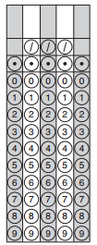

1. Given the function , find the value of *f*(3).



1. To the nearest centimeter, what is the diameter of a soccer ball given that its circumference is 69 centimeters?

(Use = 3.14)



1. Find the next *y*-value in this exponential function.

|  |  |
| --- | --- |
| ***x*** | ***y*** |
| -1 | 0.25 |
| 0 | 1 |
| 1 | 4 |
| 2 | 16 |
| 3 | 64 |
| 4 | ? |



1. Solve for *x*:



Name: _____________

TASC Math – Practice Readiness Test (V1)

**Part II – Calculator Use is NOT Allowed**

1. In the diagram below, a plane paralell to the base of a regular square pyramid intersects the pyramid as shown. What shape is formed by the intersection of the regular square pyramid and the plane?

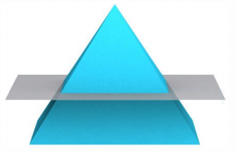

A. B. C. D.

   

1. What shape will be created by the graph of y = x2 – 10*x* + 25
2. a square with sides that measure 5 units
3. a line that crosses the *y*-axis at the point (0, 25)
4. a circle with radius 5
5. a parabola containing the point (5, 0)
6. Which of the following is equivalent to the polynomial expression below?



11. Which of the graphs below has a slope of 3?

B

A

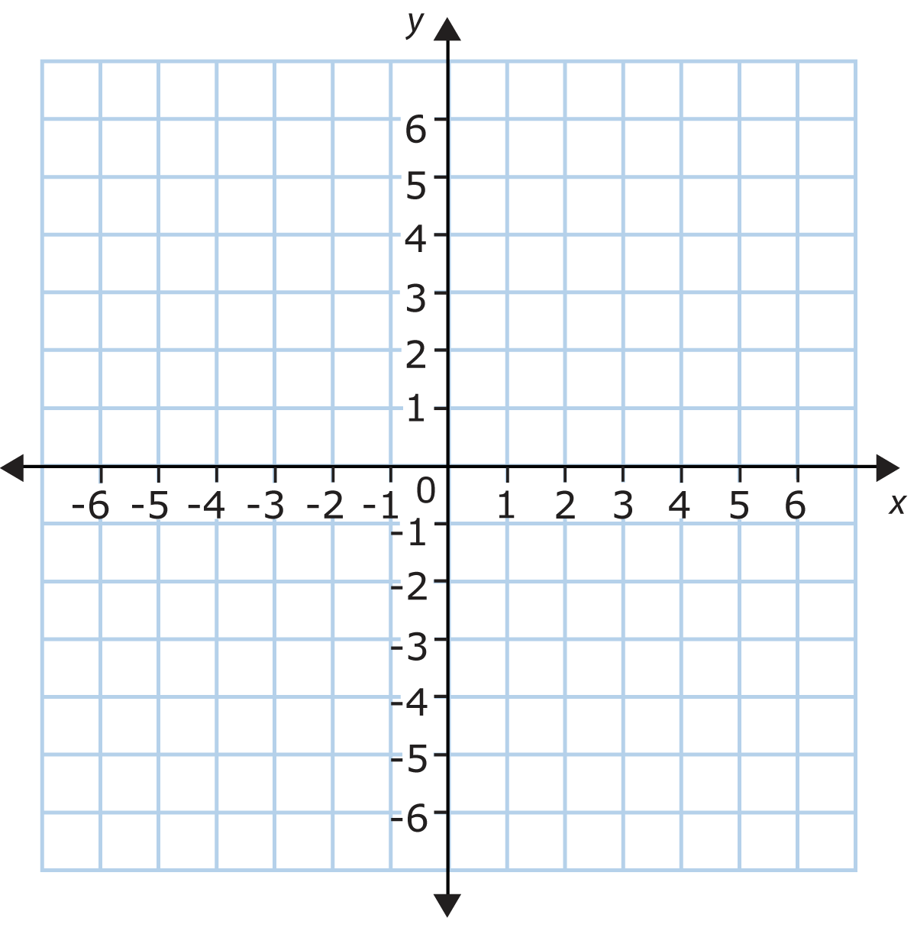



D

C



1. To find the mean *M* of three numbers, we use the formula . Which of the following formulas could be used to find the value of *z*?



6. Marlene signs a lease for an apartment in 2014.  Her monthly rent increases every year after the first.

The equation y=150x+1000 can be used to model her monthly rent, y, where x=0 represents 2014.

Which statement describes her monthly rent?

1. Her rent was $150 in 2014 and it is now $1000
2. Her monthly rent was $1000 in 2014 and it has increased by $150 per year since then
3. Her monthly rent was $150 in 2014 and has increased by $1000 per year since then
4. Her monthly rent was $1000 in 2014 and it has increased by $1.50 each year since then
5. Which of these is defined as a part of a line that has one endpoint and extends in one direction without ending?
6. arc
7. line
8. ray
9. vertex
10. Alyssa plays soccer (s) and baseball (b). She burns 400 calories/hour playing soccer and 50 calories/hour playing baseball. Each week she is willing to spend *at most* 20 hours exercising and wishes to burn *at least* 4000 calories.

Which system of inequalities can Alyssa use to determine the possible exercise plans she can have?

1. Choose the expression below that is equivalent to
2. Which of the following is an irrational number?
4. 2.875

7. Refer to the graph below:

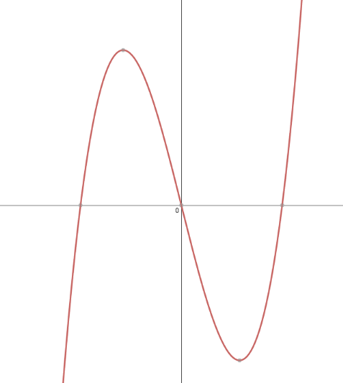

2

-2

Which function represents the graph above?

1. Nina discovered that this year, she is  the age of her mother minus her own age. How could Nina express this algebraically?


5. On the graph shown below, what is the minimum for the interval  to?

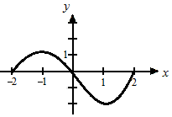

1. (2, 0)
2. (-1, 1)
3. (-2, 2)
4. (1, -2)
5. Two rectangles are similar and the dimensions shown are in centimeters.

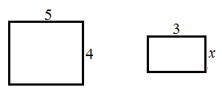

What is the measure of *x*, in centimeters?

1. 1.8
2. 2.4
3. 2.6
4. 2.8
5. Consider this inequality:

Which of these shaded half-planes represents the solution region of the inequality?

|  |  |
| --- | --- |
| A. | B. |
| C. | D. |

1. Michelle wrote the letters of her first and last name on separate cards:

M I C H E L L E L A N D R Y

Then she placed the cards face down in two piles, one for her first name, and one for her last name. If Michelle picks a card at random from each pile, what is the probability that she will choose an E and a Y?

1. 
2. 
3. 
4. 
5. Which system of equations corresponds to this graph?

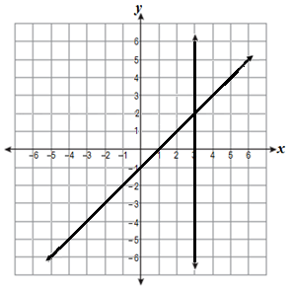

1. 
2. 
3. 
4. 
5. Imagine that this triangle rotates 360° around the *y*-axis. What three-dimensional figure will it form?

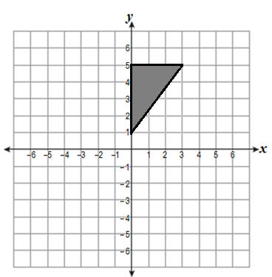

1. cone
2. prism
3. sphere
4. cylinder
5. There is a negative correlation between the number of hours a student watches television and his or her social studies test score. Which scatter plot below displays this correlation?

|  |  |
| --- | --- |
| **A** | **B** |
| **C** | **D** |

1. Which of the following best describes key features of the graph of the function shown below?

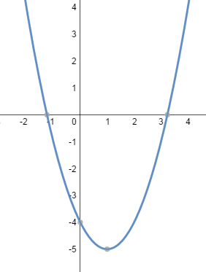

1. The vertex of the graph is found at (1, -5) and the axis of symmetry is the line y = 1.
2. The vertex of the graph is found at (1, -5) and the axis of symmetry is the line x = 1.
3. The vertices of the graph are found at -1 and 3 and the axis of symmetry is found at (1, -5).
4. The vertices of the graph are found at -1 and 3 and the axis of symmetry is found at (-5, 1).

TASC Math – In-house Practice Readiness Test (V1)

**Part II – Long Response** – Calculator Use is Not Allowed

1. An employee earns $10.50 per hour. On Monday, she works from 8:00 a.m. until 4:00 p.m., and she takes a one hour unpaid lunch break

How much does the employee earn on Monday?



1. A car can be purchased for $1090.00 in cash or financed in 24 monthly payments of $50.00.

How much would be saved by paying cash?



1. Two parallel lines are crossed by a transversal. What is the measure of angles 

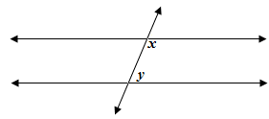



1. *AB* is a diameter of the circle below. If angle *CAB* measures 42°, what is the measure of angle *CBA*?

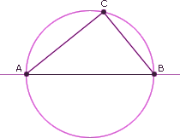



1. Austin made a scale drawing of a triangular park. The coordinates for the vertices of the park are:

(-2, 5), (10, 5), & (7, 9)

His scale is1 unit = 1 yard.

What is the area of the triangular park in square yards?



Name ____________________________________ Date ______________

**TASC Math Readiness Test (V1)**

|  |  |  |  |
| --- | --- | --- | --- |
| Part 1 | | Part 2 | |
| # | **Answer** | **#** | **Answer** |
| 1 |  | 21 |  |
| 2 |  | 22 |  |
| 3 |  | 23 |  |
| 4 |  | 24 |  |
| 5 |  | 25 |  |
| 6 |  | 26 |  |
| 7 |  | 27 |  |
| 8 |  | 28 |  |
| 9 |  | 29 |  |
| 10 |  | 30 |  |
| 11 |  | 31 |  |
| 12 |  | 32 |  |
| 13 |  | 33 |  |
| 14 |  | 34 |  |
| 15 |  | 35 |  |
| 16 |  | 36 |  |
| 17 |  | 37 |  |
| 18 |  | 38 |  |
| 19 |  | 39 |  |
| 20 |  | 40 |  |
| A |  | F |  |
| B |  | G |  |
| C |  | H |  |
| D |  | I |  |
| E |  | J |  |