F1 Unit Exam – Functions, Linear Functions, and Systems of Linear Functions

Topics Covered
Analyzing Domain and Range – Identifying functions from tables, graphs, and ordered pairs
Evaluating functions using function notation
Relating the 3-views of a linear function
Analyzing linear functions and systems of linear functions in terms of a context

Standards
F.IF.1: Understand that a function from one set (called the domain) to another set (called the range) assigns to each element of the domain exactly one element of the range. If f is a function and x is an element of its domain, then f(x) denotes the output of f corresponding to the input x. The graph of f is the graph of the equation y = f(x).
- High emphasis
- Ex. Which graph represents a function?
- Ex. Which of the following input/output relationships define a function (from data in a table).

F.IF.2: Use function notation, evaluate functions for inputs in their domains, and interpret statements that use function notation in terms of a context.
- High emphasis
- Ex. What values do the domain and range represent in the function that describes a real-life situation?

F.IF.4: For a function that models a relationship between two quantities, interpret key features of graphs and tables in terms of the quantities, and sketch graphs showing key features given a verbal description of the relationship. Key features include the following: intercepts; intervals where the function is increasing, decreasing, positive, or negative; relative maxima and minima; symmetries; end behavior; and periodicity.
- High emphasis
- Which graph represents the function?
- For which values is the function increasing?

F.IF.5: Relate the domain of a function to its graph and, where applicable, to the quantitative relationship it describes. For example, if the function h(n) gives the number of person-hours it takes to assemble n engines in a factory, then the positive integers would be an appropriate domain for the function.
- High emphasis
- Which of these functions has a domain of all real numbers?
- It takes Chris 2 minutes to read one page. What values do the domain and range represent in the function that describes how long it takes Chris to read a given amount of pages?

F-IF.7: Graph functions expressed symbolically and show key features of the graph, by hand in simple cases and by using technology for more complicated cases.
- High emphasis
- Ex. Which graph represents ...

F.LE.1: Distinguish between situations that can be modeled with linear functions and with exponential functions.
- Medium emphasis
- Ex. Which statement describes how we know this situation can be modeled by a linear function?

F.LE.2: Construct linear and exponential functions, including arithmetic and geometric sequences, given a graph, a description of a relationship, or two input-output pairs (include reading these from a table).
- Medium emphasis
- Ex. Which function describes the relationship shown in the graph/table?
- Ex. Which function represents this situation?

F.LE.5: Interpret the parameters in a linear, quadratic, or exponential function in terms of a context.
- Medium emphasis
- Based on the equation, what is the starting value?
- What is the rate of change/percent rate of change of the function?

F.BF.1: Write a function that describes a relationship between two quantities.
- Low emphasis
- Which graph represents the function that models changes in Pam’s bank account?
- Which statement is true about the given function?

F1 Unit Exam – Functions, Linear Functions, and Systems of Linear Functions
Answer Key

# | Correct | # | Correct | # | Correct | # | Correct | # | Correct | # | Correct | # | Correct
1 | D | 4 | B | 7 | 760 | 10 | C | 13 | B | 16 | C | 19 | D
2 | A | 5 | A | 8 | A | 11 | B | 14 | B | 17 | D | 20 | D
3 | B | 6 | C | 9 | D | 12 | A | 15 | A | 18 | A | 21 | D

22. Rubric

2-Points Examinee states that that function f(x) = 2.5x + 3 is incorrect and demonstrates that the correct function rule is f(x) = 3x + 2.5.
1-Point Examinee states the function rule f(x) = 2.5x + 3 is incorrect, but does not demonstrate the correct function rule f(x) = 3x + 2.5.

EXTRA CREDIT

23. C

24. C

25. 41

Name __________________________ Date _____________________________

F1 Unit Exam – Functions, Linear Functions, and Systems of Linear Functions

- Which of these tables of values represents a function?

A.  Input Output  3 2  9 4  -6 8  3 9 | B.  Input Output  -4 8  -2 4  0 0  -2 -4 | C.  Input Output  8 6  6 8  4 8  8 4 | D.  Input Output  2 6  8 24  10 30  -6 9

- Which of these sets of ordered pairs represents a function?

- {(3, -2), (4, 1), (5, -1), (6, 9)}
- {(6, -8), (6, -3), (6, 3), (6, 2)}
- {(9, 2), (5, -1), (9, -1), (8, 10)}
- {(3, -1), (8, 1), (8, 3), (1, 9)}

- Given the relation G = {(-4, 5), (8, 2), (a, 7), (1, 3)}. Which replacement for a makes this relation a function?

- 1
- 2
- -4
- 8

- Which graph does NOT represent a function?
A.  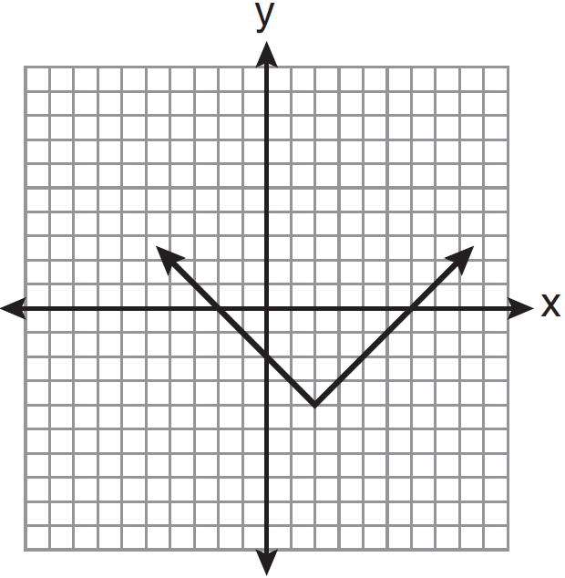 | B.  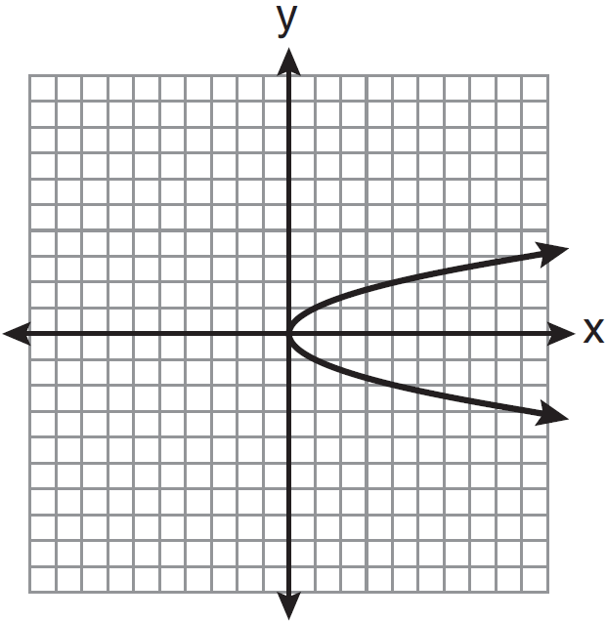 | C.  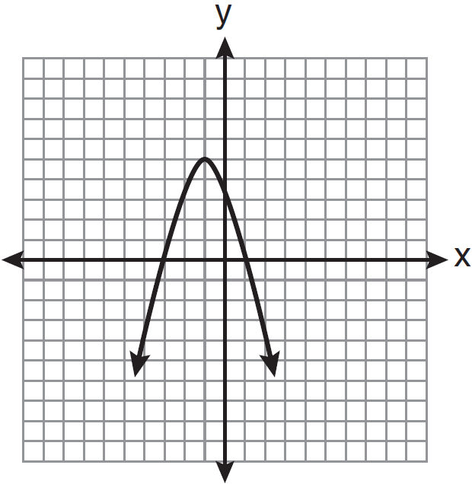 | D.  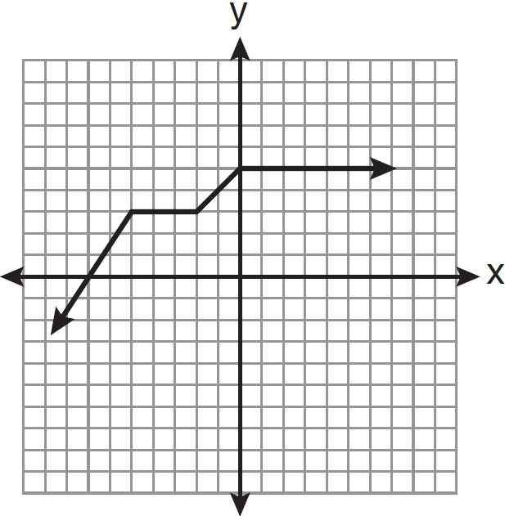

- For the function $g\left(x\right)= 3x-21$, what is $g(6)$?

- -3
- 3
- 9
- 12
- For the function $f\left(x\right)= \frac{2}{3}x+14$, what is $f(18)$?

  - 6
  - 8
  - 26
  - 38

- The function below can be used to predict the number of antibodies that should be present in a patient’s blood d days after taking a particular medicine.  f(d) = 60d + 100  Using the given function, how many antibodies are predicted to be in the patient’s blood after 11 days? | 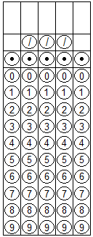
- Which of the following solutions would belong to the solution set for the linear function associated with the table of values below?
x y  4 11  5 15  6 19  7 23 | - (3, 7)  - (1, 8)  - (6, 16)  - (8, 24)

- Which function matches the x and y values shown in the accompanying table of values?
x y  1 3  2 5  3 7  4 9 | - x = y + 2  - y = x + 2  - x = 2y  - y = 2x + 1

- Which graph models the function that has (0, 3), (-2, -1), and (1, 5) included in its solution set?
A.  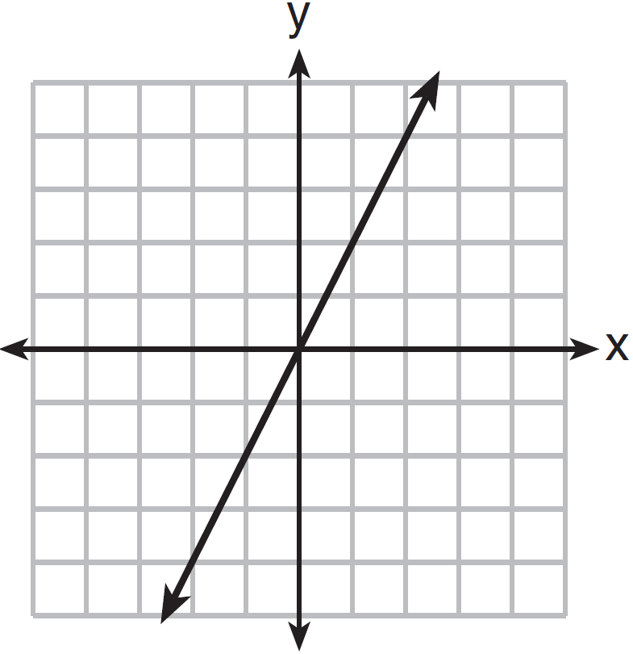 | B.  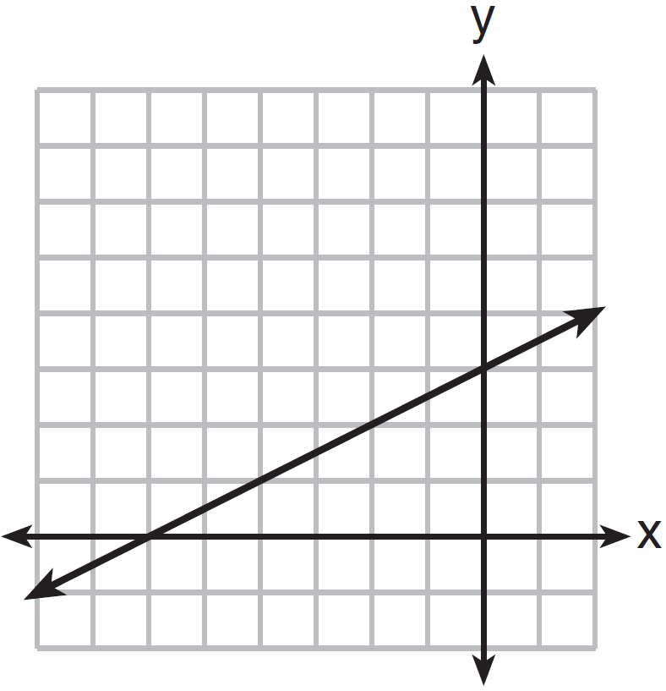
C.  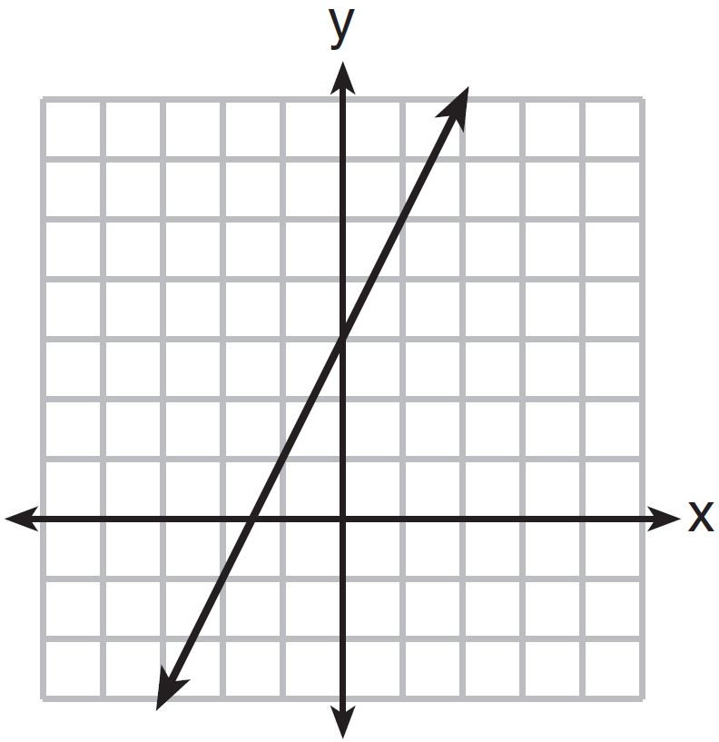 | D.  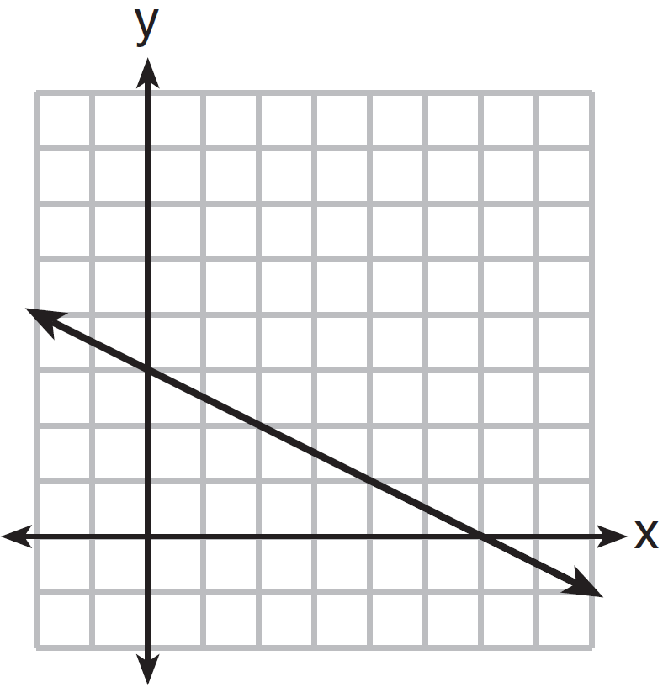

- The table below gives selected values for the linear function, .
x
12 | 18
13 | 20
14 | 22
15 | 24

Which of the following functions has the same slope as ?

- Which function matches the x and y values shown in the accompanying table of values?
x y  4 7  6 8  8 9  10 10 | - y = $\frac{1}{2}$x + 5  - x = 2y  - y = x + 2  - x = y + 1

- Given the graph to the right, find f(-3).  - -6  - -1  - 3  - 4 | 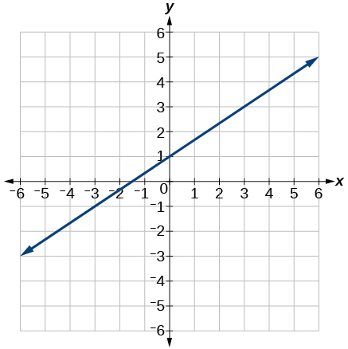

- Hector makes a living by selling fish tanks. He gets paid a commission every time he sells a fish tank as well as a base salary that he receives every month. The equation y = 50x + 600 can be used to model his monthly salary, with x representing the number of fish tanks Hector sells in a month, and y represents Hector’s monthly salary. Which statement describes Hector’s monthly salary?

- He gets paid $650 a month.
- He gets paid $50 for every fish tank he sells plus $600 dollars a month as a base salary.
- He gets paid $600 for every fish tank he sells plus $50 a month as a base salary.
- He gets paid for 12 fish tanks.

- The cost of riding in a taxi-cab in Center City can be modeled by the linear equation y = $3x + $2.75 where x represents the number of miles travelled in the taxi and y represents the total cost of the taxi ride. Which interpretation of this linear model is correct?

- The taximeter starts at $2.75 and goes up $3.00 for each mile that is driven.
- The taximeter starts at $3.00 and goes up $2.75 for each mile that is driven.
- The taximeter starts at $0.00 and goes up $3.00 for each mile that is driven.
- The taximeter starts at $0.00 and goes up $5.75 for each mile that is driven.
- The gas tank in a car holds a total of 16 gallons of gas. The car travels 75 miles on 4 gallons of gas. If the gas tank is full at the beginning of a trip, which graph represents the rate of change in the amount of gas in the tank?
A.  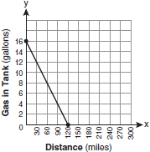 | B.  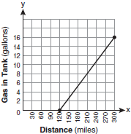
C.  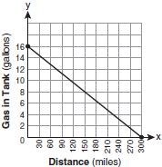 | D.  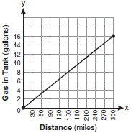
- The results of an experiment testing the effectiveness of a medication in raising the number of antibodies in a sample of blood are shown in the graph to the right.  Which of the following functions correctly models the relationship between d, the days that have passed in the experiment, and a, the number of antibodies in the sample of blood?  - d = 70a + 50  - d = 50a + 70  - a = 70d + 50  - a = 50d + 70 |  | 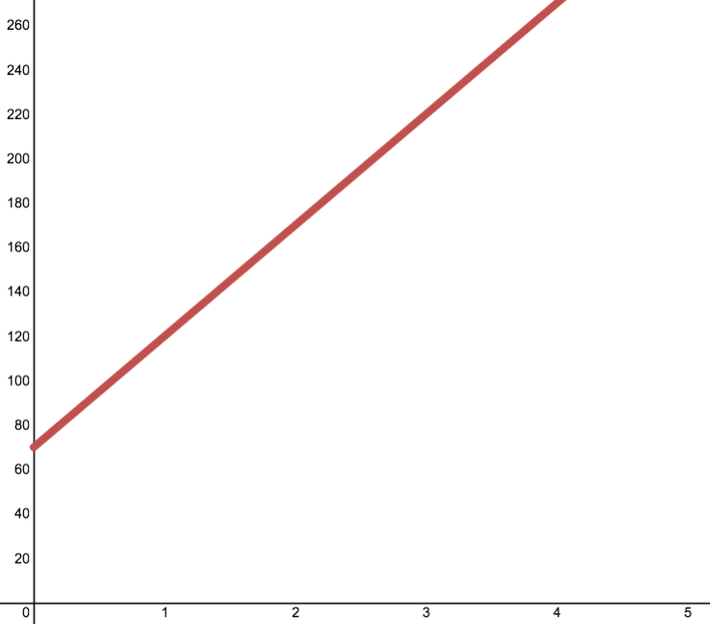  Antibodies in a Sample of Blood  Days Passed in Experiment

- Eric and Nancy both sell fish tanks. Eric receives a monthly base pay of $1400, plus a commission of $75 for every fish tank that he sells. His total salary in a given month can be found using the function

y = 75x + 1400 where x is the number of fish tanks Eric sells and y is his total monthly salary.

Nancy, on the other hand, does not receive a base pay, but gets a commission of $250 for every fish tank that she sells. Her total salary in a given month can be found using the function

y = 250x where x is the number of fish tanks Nancy sells and y is her total monthly salary.

Last month, Eric and Nancy each sold the same number of fish tanks and also earned the same salary. Which statement most accurately reflects the number of fish tanks sold and amount of money earned by Eric and Nancy last month?

- Eric and Nancy each sold 8 fish tanks and each earned $2000.
- Eric and Nancy each sold 10 fish tanks and each earned $2500.
- Eric sold 4 fish tanks and earned $1700. Nancy sold 4 fish tanks and earned $1000.
- Eric sold 28 fish tanks and earned $3500. Nancy sold 14 fish tanks and earned $3500.

- Consider this system of equations:

f(x) = 10x + 80
g(x) = 20x + 60

What is the solution to the system of linear equations?

- (100, 2)
- (90, 80)
- (30, 140)
- (2, 100)

- Joey, J, ate 18 more hot dogs than Kobayashi, K. Together they ate 129 hotdogs. Which system of equations could be used to find out how many hot dogs they each ate?
- J + K = 129

- K = J + 18
J + K = 129

- J + K = 129
J = 18

- J = K + 18
J + K = 129
- A research scientist testing medicines determined that the following function represents the number of antibodies in a sample of blood from a patient after taking Medicine C:
C(d) = 40d + 80
In this function, d represents the number of days that the patient has been on the medication, and C(d) represents the number of antibodies in a sample of the patient’s blood.
The scientist then determined that the following function represents the number of antibodies in a sample of blood from a patient after taking Medicine E:

E(d) = 35d + 140

Which of the following statements is accurate?

- After 40 days, the sample of blood from the patient that took Medicine C had 80 antibodies.
- After 35 days, the sample of blood from the patient that took Medicine E had 140 antibodies.
- After 560 days both samples of blood contained 12 antibodies.
- After 12 days both samples of blood contained 560 antibodies.

- The cost to ride in a taxicab in Hyuga City is $2.50 plus $3 per mile for each mile travelled.
On a math test, Lizette stated that the function rule f(x) = 2.5x + 3 could be used to calculate the cost of travelling in a taxi in Hyuga City for x miles. However, her teacher marked her answer as incorrect. Is her function rule correct? If so, demonstrate how you know below. If it is not correct, write a mathematical function that could be used to calculate the cost of travelling x miles in a taxi in Hyuga City.

EXTRA CREDIT
- The system of equations y = x² + 2x – 15 and  y = x + 5 are graphed at right.  Which of the following are true about the solutions to the system of equations shown?  - The only solution to the system of equations is found at (-5, 0)  - The two solutions to the system of equations are found at (-5, 0) and (3, 0)  - The two solutions to the system of equations are found at (-5, 0) and (4, 9)  - The three solutions to the system of equations are found at (-5, 0), (4, 9) and  (3, 0) | 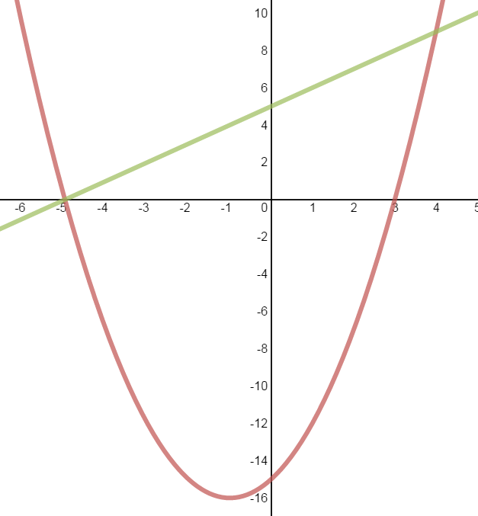

- Which function matches the x and y values shown in the accompanying table of values?
x y  0 2  1 3  2 6  3 11 | - y = x + 2  - y = x²  - y = x² + 2  - y = 2^{x}

- Fred, F, can do 18 more pushups than Tye, T. Together they did a total of 64 pushups. How many pushups did Fred do?

F1 Unit Exam – Functions, Linear Functions, and Systems of Linear Functions
Score Sheet and Report

# | Answer |  | Subdomain Score | Subdomain
1 |  |  | /4 % | Analyzing Domain and Range
2
3
4
5 |  |  | /3 % | Evaluating Functions Using Function Notation
6
7
8 |  |  | /6 % | Relating the 3-Views of Linear Functions
9
10
11
12
13
14 |  |  | /8 % | Analyzing Linear Functions and Systems of Linear Functions
15
16
17
18
19
20
21
22 |  | Constructed Response – Record Your Answer Below
 |  | /2
23 |  |  | + | Extra Credit
24
25
Total |  |  | /23 %

