Name: _________________________ Date: ___________________________
TASC Math Practice Test V4 - GHI & JKL Aligned
Part I – Calculator Use Allowed
- Which set of ordered pairs below represents a function?

- {(3, 8), (3, 9), (3, 10), (3, 11)}
- {(0.5, 7), (4, 9), (5, 10), ($\frac{1}{2}$, 9)}
- {(4, 5), (3, 2), (4, 7), (5, 3)}
- {(8, 2), (3, 7), (-1, 2), (2, 8)}

- Which expression below is equivalent to $\frac{4^{3}}{4^{-5}}$?

- $4^{8}$
- $4^{2}$
- $4^{-2}$
- $4^{-8}$

- What is the solution to the system of equations below?

$$2x-y=3$$
$$x-y=1$$

- x = 2, y = -1
- x = 1, y = 2
- x = -2, y = 1
- x = 2, y = 1

- For what value of x is $f\left(x\right)=\frac{12x+2}{5+ x}$ undefined?

- 0
- –5
- 5
- 6

- Consider the steps that a student wrote as he solved the equation: 5a + 3 = 33.

Equation: 5a + 3 = 33
Step 1: 5a = 30
Solution: a = 6

Which statement explains why the solution following Step 1 is a valid step?

- If you add 3 to both sides of an equation, the sides remain equal.
- If you divide both sides of an equation by 5, the sides remain equal.
- If you multiply both sides of an equation by 5, the sides remain equal.
- If you subtract 3 from both sides of an equation, the sides remain equal.

- The depreciation of the value of certain model car can be modeled by the function $D\left(t\right)={(0.92)}^{t}$, where D(t) is the value of the car and t is the time in years.

What is the percent change in the value from one year to the next, and does this represent exponential growth or decay?

  - 8%; exponential decay
  - 8%; exponential growth
  - 92%; exponential decay
  - 92%; exponential growth

- Joey, J, ate 13 more hot dogs than Kobayashi, K. Together they ate 125 hotdogs. Which system of equations could be used to find out how many hot dogs they each ate?

- J + K = 125
J = K – 13
- K = J + 13
J + K = 125
- J + K = 125
J = 13
- J = K + 13
J + K = 125

- Given the equation: $\sqrt{5x-20}=10$

What is the value of x that will make the equation true?

- 2
- 6
- 24
- 100

- Find the perimeter of $∆$MNO below.

- 17
- 29
- 30
- 60

- Which of the following is equivalent to the equation $x^{2}-12x+36=0$?

- ${\left(x+6\right)}^{2}=0$
- ${(x-6)}^{2}=0$
- $(x-6)(x+6)=0$
- $(x-18)(x-2)=0$

- In Hong Kong about 7.8 million people live in 426 square miles. What is the approximate population density per square mile of Hong Kong?

- 1.83 people per square mile
- 183 people per square mile
- 18,300 people per square mile
- 1,800,000 people per square mile

- The longest side of a right triangle is 20 inches. One of the legs of the right triangle measures 12 inches. What it the length of the other leg?

- 8 in.
- 16 in.
- 23 in.
- 32 in.

- Solve for x: x² – 12x + 27 = 0

- x = {-9, 3}
- x = {9, -3}
- x = {-9, -3}
- x = {9, 3}

- Find the volume of the figure below.
- $\frac{56}{3}$ in³  - 48 in³  - $56$in³  - $112$ in³ | 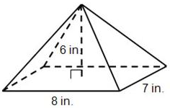

- A circle has a radius of 10cm. How long is the arc subtended by a central angle of $90°$?

- $2.5π$
- $5π$
- $10π$
- $20π$
- Refer to the table below.

Number of Children Living in a Household
Children | Households
0 | 37
1 | 10
2 | 12
3 | 6
4 | 3
≥5 | 2
Total | 70

The table above shows the number of households in a community that have 0, 1, 2, 3, 4, or ≥5 children living in the household. What is the relative frequency of households that have at least 3 children in them in this community?

- 0.07
- 0.09
- 0.16
- 0.84

- Which names the function for the arithmetic sequence below?

3, -2, -7, -12 . . . . .

- $f\left(n\right)=8-5n$
- $f\left(n\right)=3-3n$
- $f\left(n\right)=3-8n$
- $f\left(n\right)=-3+8n$

- . Steel has a density of about 7.75 grams per cubic centimeter. To the nearest gram, what is the mass of a cylinder with 4 cm radius and 20 cm high?

- 206 grams
- 620 grams
- 7,787 grams
- 107,136 grams

- Refer to the graph below.
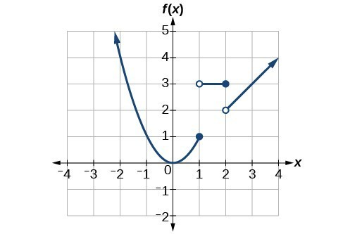
Given the graph above, find f(2).

- 1
- 2
- 3
- 4

- The table below gives selected ordered pairs for the linear function .

x
20 | 5
23 | 7
26 | 9
29 | 11

Which of the following functions has the same slope as?

- $g\left(x\right)=x+7$
- $h\left(x\right)=2x+2$
- $q\left(x\right)=\frac{2}{3}x+8$
- $p\left(x\right)= \frac{3}{2}x+5$

TASC Math Practice Test V4 (G, H, I Aligned)
Part I – Long Response – Calculator Use Allowed
- Consider the equation below.  $$4\left(x+10\right)=5x+3$$  What value of x will make the equation true? | 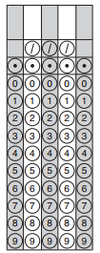
- Given the function $f\left(x\right)={2x}^{3}+x^{2}-3x$, find the value of f(5).

- Ronaldo is standing by the edge of a circular lake at point A (shown below). He has to get directly to the other side at point B. Instead of walking around the lake from A to B, he decides that he would rather swim. How far must he swim from A to B if the circumference of the lake is 4.71 miles? (Use $π$ = 3.14)

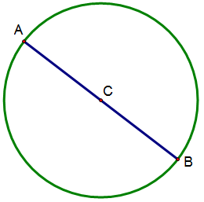

- Exactly 40% of the students at North Shore High School are male. Of the male students at North Shore High School, only $\frac{1}{5}$ of them elect to take chemistry. What are the chances that a student at North Shore High School, selected at random, is both male and taking chemistry?

- Lando is travelling on a bicycle at an average rate of 8 mph. How many minutes does it take him to ride home which is 5 miles away?

Name: _______________________ Date: _______________________
TASC Math – Practice Test V4 (G, H, I Aligned)

Part II – Calculator Use is NOT Allowed

- Which of the following is a rational number?

- $\sqrt{3}$
- $\sqrt{5}$
- $\sqrt{9}$
- π

- What shape will be created by the graph of $y=\left|x\right|+3$

- a V-shaped graph that crosses the y-axis at the point (0, 3)
- a straight line that crosses the y-axis at the point (0, 3)
- a Ʌ-shaped graph that crosses the y-axis at the point (0, 3)
- a U-shaped graph that crosses the y-axis at the point (0, 3)

- Which of the following is equivalent to the polynomial expression below?

$$\left(-4m^{5}n^{3}+10m^{4}n^{2}\right)-(3m^{5}n^{3}-6m^{4}n^{2}+m)$$

- $-7m^{5}n^{3}+{16m}^{4}n^{2}-m$
- $-7m^{10}n^{6}+{16m}^{8}n^{4}-m$
- $-m^{5}n^{3}+{4m}^{4}n^{2}-m$
- $-m^{10}n^{6}+{4m}^{8}n^{4}-m$

- Hector makes a living by selling fish tanks. He gets paid a commission every time he sells a fish tank as well as a base salary that he receives every month. The equation y = 50x + 600 can be used to model his monthly salary. Which statement describes Hector’s monthly salary?

- He gets paid $650 a month.
- He gets paid $50 for every fish tank he sells plus $600 dollars a month as a base salary.
- He gets paid $600 for every fish tank he sells plus $50 a month as a base salary.
- He gets paid for 12 fish tanks.

- Which of the graphs below has a slope of $-\frac{1}{2}$?
A.  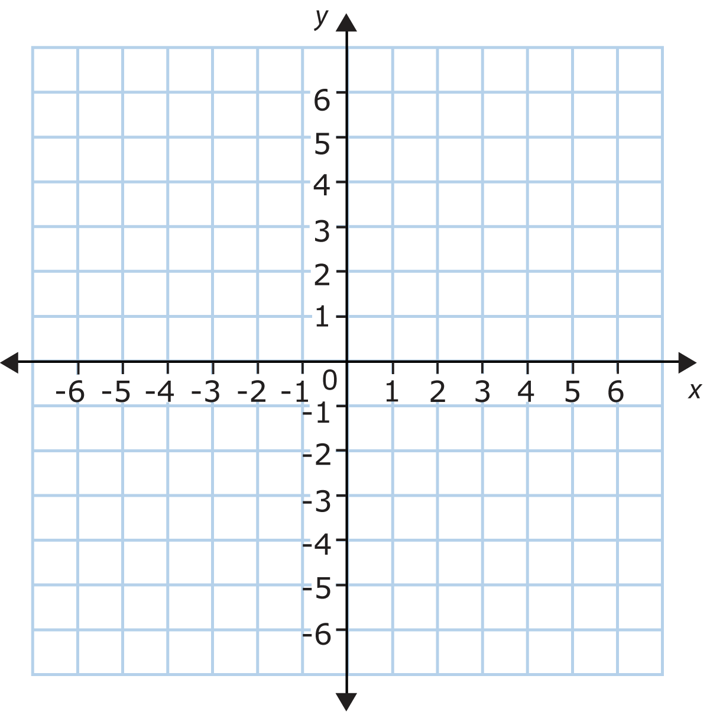 | B.
C. | D.
- In a molecule of water, there are two atoms of hydrogen and one atom of oxygen. How many atoms of hydrogen are in 16 molecules of water?

- 8
- 16
- 32
- 48
- Which of these could be considered an equiangular quadrilateral?

- An equilateral triangle
- A rectangle
- A trapezoid
- A square

- Only I
- II and III
- II, III, and IV
- II and IV

- Destiny has $10 to spend on candy (c) and a sandwich (s). Which inequality can be used to represent how much money Destiny can spend on candy after she buys a sandwich?

- $s≤c+10$
- $c≤10-s$
- $s≥10-c$
- $c≤10+s$

- Choose the expression below that is equivalent to $\frac{p^{3}{\left(m^{-2}n^{4}\right)}^{3}}{n^{-2}}$

- $m^{-6}n^{14}$
- $-p^{3}mn^{5}$
- $p^{3}m^{-6}n^{14}$
- $p^{9}m^{-6}n^{10}$

- The formula to convert degrees Celsius, C, to degrees Kelvin, K, is$K=C+273.15$. Given that fact, which of the following equations could be used to convert degrees Kelvin to degrees Celsius?

- $C=K-273.15$
- $C=K+273.15$
- $C=273.15-K$
- $C=K÷273.15$

- Refer to the graph below:

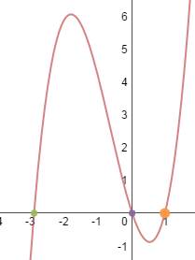

Which function represents the graph above?

- $f\left(x\right)=x+3$
- $f\left(x\right)=x^{2}+2x-3$
- $f\left(x\right)=x^{3}+2x^{2}-3x$
- $f(x)=x^{3}+27$

- The noon temperature Monday was 69°F. Tuesday the noon temperature was 71°F. Wednesday it was 56°F, Thursday it was 63°F, and Friday it was 66°F. Which of the following is the most accurate measure of the temperature for these five days?

- The mean temperature and median temperature were the same.
- The mean temperature was greater than the median temperature.
- The mean temperature was less than the median temperature.
- There is not enough information to determine both the mean and median temperature.

- Which of the following best describes key features of the graph of the function
$f\left(x\right)={-x}^{2}+2x+3$ shown below?

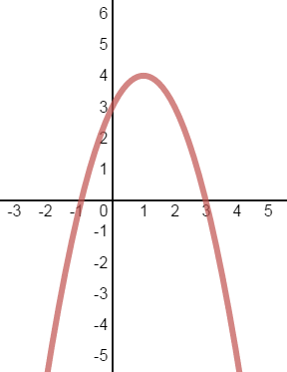

- The axis of symmetry is x = 1 and the maximum is (1, 4)
- The axis of symmetry is y = 1 and the maximum is (1, 4)
- The axis of symmetry is x = 1 and the minimum is (1, 4)
- The axis of symmetry is y =1 and the minimum is (1, 4)

- Thayer needs to buy an exhaust fan for her bathroom. The bathroom has a width of 7 feet, a length of 10 feet, and a height of 8 feet, and the duct for the fan is 10 feet long. Using the chart below, what size bathroom fan should she purchase?

Bathroom Fan Sizing Chart
Bathroom Size | Duct Length
 | 10 ft. | 20 ft. | 30 ft. | 40 ft. | 50 ft.
400 ft³ | 60 cfm | 60 cfm | 60 cfm | 60 cfm | 60 cfm
480 ft³ | 60 cfm | 60 cfm | 60 cfm | 60 cfm | 60 cfm
560 ft³ | 70 cfm | 70 cfm | 90 cfm | 90 cfm | 110 cfm
640 ft³ | 90 cfm | 90 cfm | 90 cfm | 90 cfm | 110 cfm
730 ft³ | 90 cfm | 90 cfm | 110 cfm | 110 cfm | 110 cfm

- ≥ 60 cfm
- ≥ 70 cfm
- ≥ 90 cfm
- ≥ 110 cfm

- Refer to the graph below.
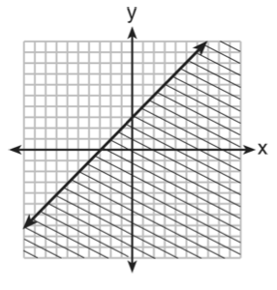
Which of the following functions could represent the inequality shown above?

- $y>x+3$
- $y≥x+3$
- $y<x+3$
- $y≤x+3$

- Salvatore wrote the letters of his first and last name on separate cards:

S A L V A T O R E L A M I

Then he placed the cards face down in two piles, one for his first name, and one for his last name. If Salvatore picks a card at random from each pile, what is the probability that he will choose a T and an M?

- $\frac{1}{4}$
- $\frac{1}{36}$
- $\frac{2}{13}$
- $\frac{13}{36}$

- The system of equations y = x² + 2x – 15 and y = x + 5 are graphed below.

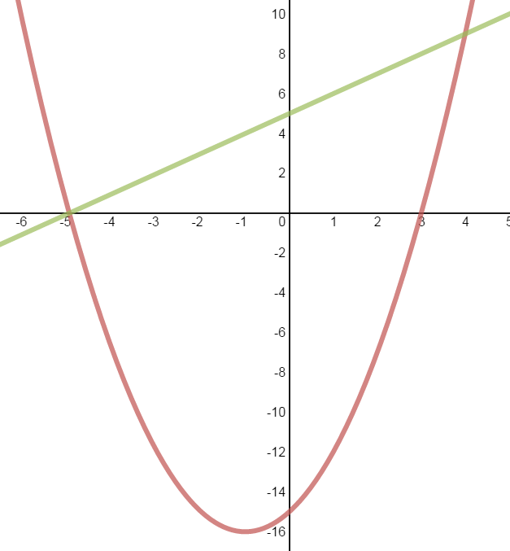

Which of the following are true about the solutions to the system of equations shown above.

- The only solution to the system of equations is found at (-5, 0)
- The two solutions to the system of equations are found at (-5, 0) and (3, 0)
- The two solutions to the system of equations are found at (-5, 0) and (4, 9)
- The three solutions to the system of equations are found at (-5, 0), (4, 9) and (3, 0)

- The cost of riding in a taxi-cab in Center City can be modeled by the linear equation y = $3x + $2.75 where x represents the number of miles travelled in the taxi and y represents the total cost of the taxi ride. Which interpretation of this linear model is correct?

- The taxi meter starts at $2.75 and goes up $3.00 for each mile that is driven.
- The taxi meter starts at $3.00 and goes up $2.75 for each mile that is driven.
- The taxi meter starts at $0.00 and goes up $3.00 for each mile that is driven.
- The taxi meter starts at $0.00 and goes up $5.75 for each mile that is driven.

- Researchers attempted to study whether or not there was a correlation between the average time a person spends watching TV a week and the size of the television that they own. The results of their study are shown in the scatter plot below.
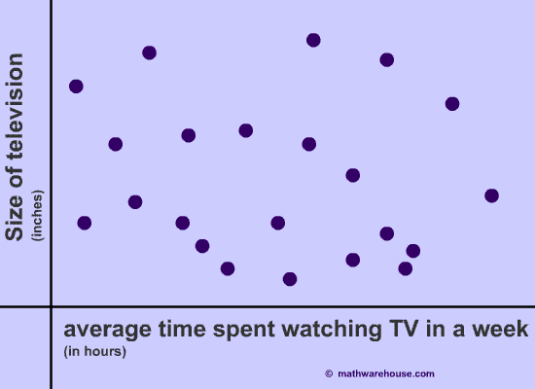

Based on the scatter plot, which statement would most closely fit the results of the study?

- The more someone watches television the larger the TV they own.
- The less someone watches television the smaller the TV they own.
- There is a negative correlation between the amount of time someone watches television and the size of the TV they own.
- There is no correlation between the amount of time someone watches television and the size of the TV they own.

- A rectangle is rotated 360° about an axis as shown.

What solid is generated by this rotation?  - cylinder  - cone  - sphere  - hemisphere | 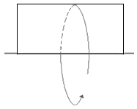

TASC Math – Practice Readiness Test V4 (G, H, I Aligned)
Part II – Long Response – Calculator Use is Not Allowed
- An employee earns $12.50 per hour. On Tuesday, he works from 9:00 a.m. until 5:00 p.m., and he takes a one hour unpaid lunch break
How much does the employee earn on Tuesday?

- Leon has the choice of buying a couch for $2200 cash, or paying a down payment of $600 plus $50/month for 36 months for the same couch. How much more will the more expensive option cost Leon?

- The equation below can be used to predict the number of antibodies that should be present in a patient’s blood d days after taking a particular medicine.

a = 60d + 100

Using the given function, how many antibodies are predicted to be in the patient’s blood after 11 days?

- If figure ABCD below is reflected in the y-axis to form the image A’B’C’D’, what are the coordinates of B’?

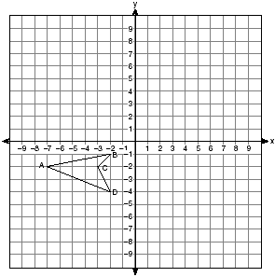

- Similar triangles ABC and PQC are shown below. They are not drawn to scale.

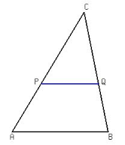

Given that $\overline{CQ}=8 cm$, $\overline{QB}=4 cm$, and
$\overline{PQ}=6cm$, what is the length of $\overline{AB}$?

Name ____________________________________ Date ______________
TASC Math Practice Test V4 (G, H, I Aligned)
Part 1 |  | Part 2
# | Answer | # | Answer
1 |  | 26
2 |  | 27
3 |  | 28
4 |  | 29
5 |  | 30
6 |  | 31
7 |  | 32
8 |  | 33
9 |  | 34
10 |  | 35
11 |  | 36
12 |  | 37
13 |  | 38
14 |  | 39
15 |  | 40
16 |  | 41
17 |  | 42
18 |  | 43
19 |  | 44
20 |  | 45
21 |  | 46
22 |  | 47
23 |  | 48
24 |  | 49
25 |  | 50

