Unit F3: Functions – Cubic, Piece-wise, Square Root and Cubic Root Functions

Topics Covered
- Identify key features, including x-intercepts, y-intercepts, domain, range, relative maxima, relative minima, and end behavior, of the graphs of cubic, piece-wise (including absolute value), square root and cubic root functions
- Graph cubic, piece-wise, square root and cubic root functions.

Standards

F-IF.7: Graph functions expressed symbolically and show key features of the graph, by hand in simple cases and by using technology for more complicated cases.

b: Graph square root, cube root, and piecewise-defined functions, using step functions and absolute value functions.
- Low Emphasis
- Which function is represented by the graph?

c: Graph polynomial functions, identifying zeros when suitable factorizations are available, and showing end behavior.
- Low Emphasis
- Which graph shows a quadratic function with zeroes at ….
- What happens to the function …. when the values of x are very large?

Answer Key

# | Correct | # | Correct | # | Correct | # | Correct | # | Correct
1 | A | 5 | D | 9 | C | 13 | C | 17 | B
2 | D | 6 | A | 10 | B | 14 | D | 18 | C
3 | C | 7 | B | 11 | B | 15 | B | 19 | A
4 | B | 8 | D | 12 | A | 16 | C | 20 | B

21. Rubric

2-Points: Correctly matches both graphs to their functions and provides evidence.

1-Point: Correctly matches both graphs to their functions.

EXTRA CREDIT

22. B

23. D

Name __________________________ Date _____________________________

Unit F3: Cubic, Piece-wise, Square Root and Cubic Root Functions

- Does the graph represent y as a function of x?  - Yes, because for every x-value there is only one y-value.  - Yes, because for every y-value there is only one x-value.  - No, because there are two y-values for the same x-value.  - No, because there are two x-values for the same y-value. | 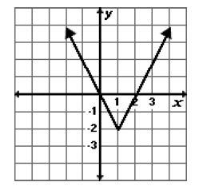

- What are the coordinates of a relative maximum shown on the graph below?  - (1, 3)  - (3, 1)  - (5, 1)  - (1, 5) | 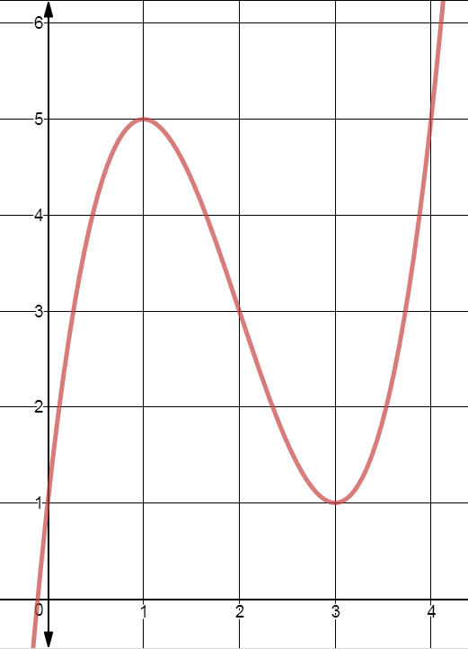

- What is the minimum value of the function y = |x + 3| – 2?

- 2
- 3
- -2
- -3

- Which of the following best describes the graph shown below?  - A relative maximum is (2,0), and the function is quadratic.  - A relative maximum is (0,6), and the function is cubic.  - A relative minimum is (-3,0), and functions is cubic.  - A relative maximum is (6,0), and function is quadratic. | 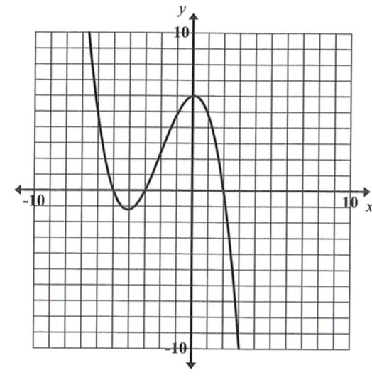

- The graph of the function f (x) = $\sqrt{x+4 }$ is shown below.  The domain of the function is:  - {x| x > 0}  - {x| x $≥$ 0}  - {x| x > -4}  - {x| x $≥$ -4} | 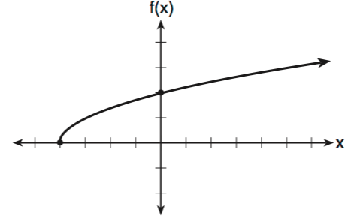

- Which inequality best represents the domain of the function shown on the graph below?  - -1 $≤$ x $≤6$  - -1 $≤$ y $≤6$  - 2 $≤$ x $≤5$  - 2 $≤$ y $≤5$ | 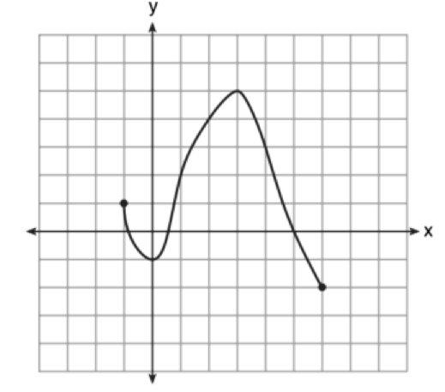

- The graph of the function f(x) = x³ is shown below. Which statement is true in reference to the graph?

- The graph is not a function.  - The function is increasing across the domain.  - The function has a negative coefficient.  - The y-intercept is 0. | 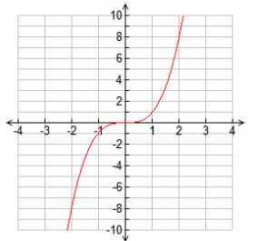

- The graph of y = f(x) is shown below.

Which set lists all the real solutions of f(x) = 0?
- {- 3, 2}  - {- 2, 3}  - {- 3, 0, 2}  - {- 2, 0, 3} | 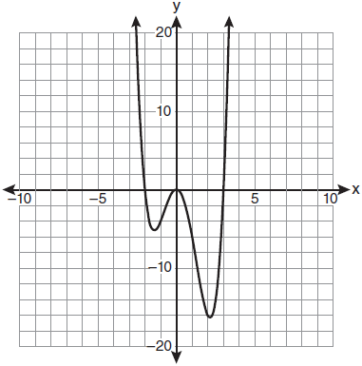

- The graph of the polynomial function f(x) = x³ + 4x² + 6x + 4 is shown below. What is the real solution?

- x = 4  - x = 0  - x = -2  - x = 2 | 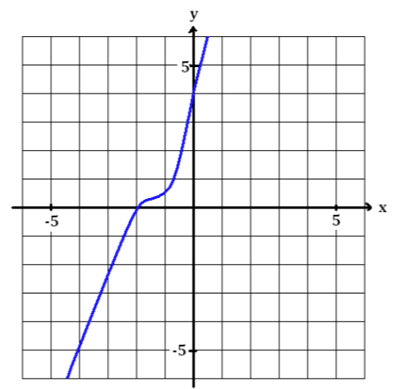

- The graph of the function f(x) = -x³ – 6x² – 12x – 8 is shown below. What is the solution to the function?

- (0, -8)  - (-2, 0)  - (-1, -6)  - (0, -2) | 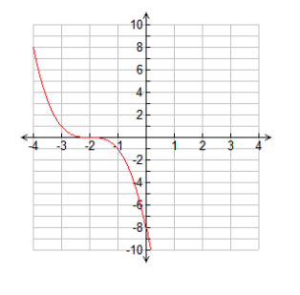

- What is the product of the roots of the equation x³ – 4x² + x + 6 = 0 whose graph is shown below?  - -36  - -6  - 6  - 4 | 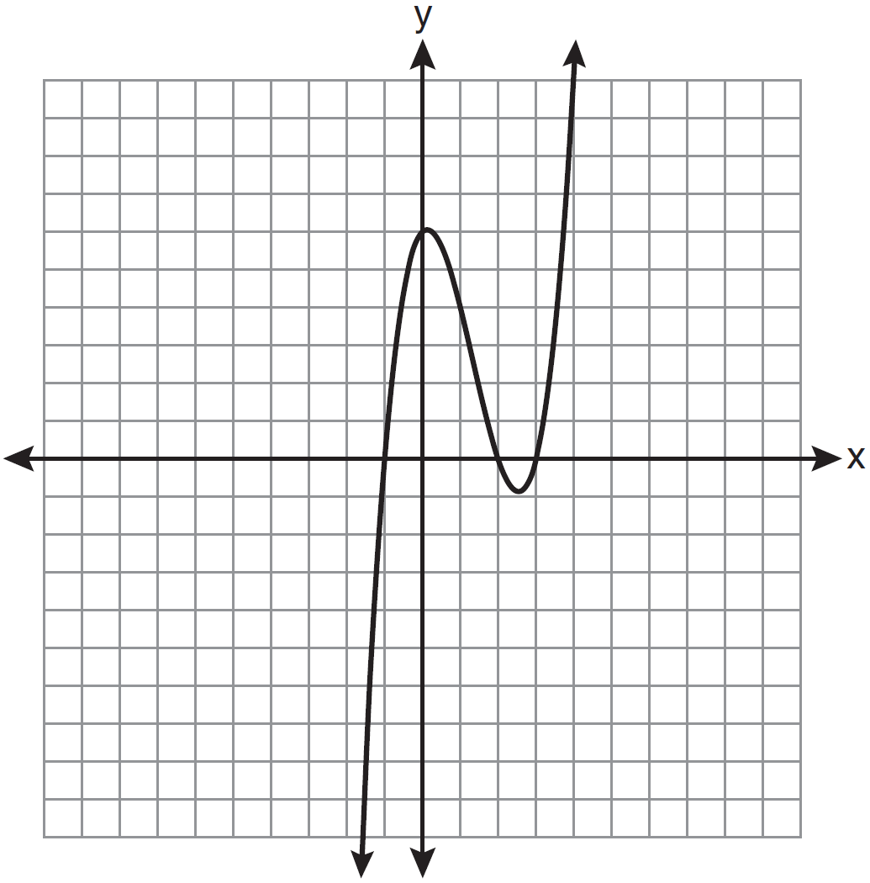

- Which choice gives the roots of the function P(x) = x³ + 6x² + 8x?

- {-4, -2, 0}
- {-4, 0, 2}
- {0, 2, 4}
- {-2, 0, 4}

- Which statement describes the graph of the function y = $\sqrt{x +4}$ – 1?

- The x-intercept is (3, 0) and the y-intercept is (0, -1)
- The x-intercept is (1, 0) and the y-intercept is (3, 0)
- The x-intercept is (-3, 0) and the y-intercept is (0, 1)
- The x-intercept is (-1, 0) and the y-intercept is (-3, 0)

- Which function represents the graph below?  - f(x) = x³ – 6x² – x + 7  - f(x) = x³ – x² – 5x – 6  - f(x) = x³ – 6x² – x + 6  - f(x) = x³ – 2x² – 5x + 6 | 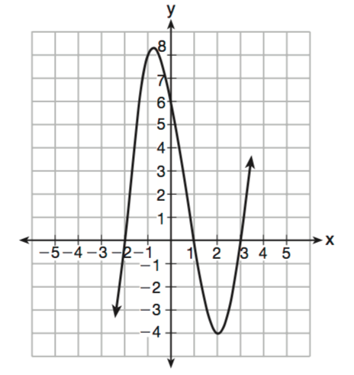

- Which function represents the graph below?

- y = (x – 1)(x + 2)(x + 3)
- y = (x + 1)(x – 2)(x – 3)
- y = (x – 1)(x + 2)(x – 3)
- y = (x + 1)(x – 2)(x + 3)

- Which equation is represented by the graph below?  - y = x² – 3  - y = (x – 3)²  - y = |x| – 3  - y = |x – 3| | 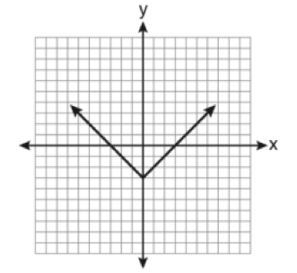

- Which is the graph of y = |x| + 2?

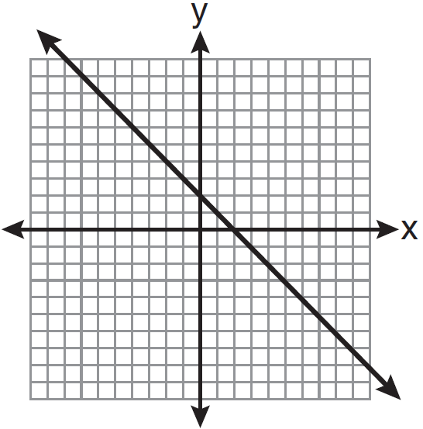 | 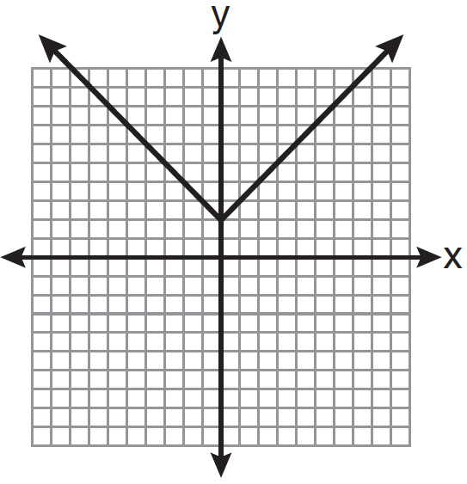
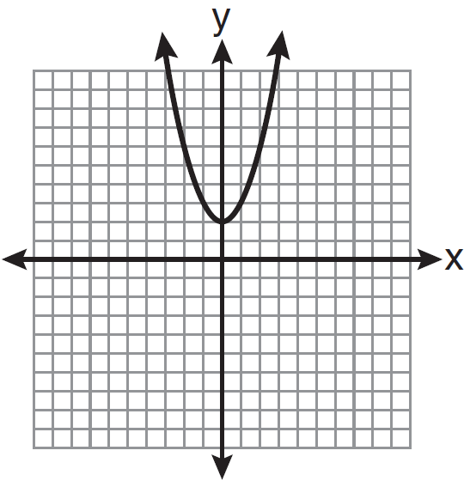 | 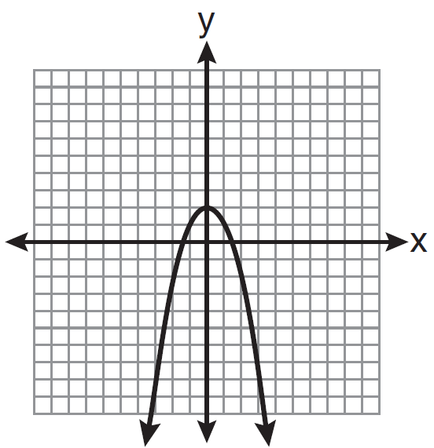

- Which equation matches the graph below?  - y = x³ + 2x² + x +2  - y = $\sqrt{2x+1}$ +2  - y = 2|x – 2|  - y = -2x² + x + 4 | 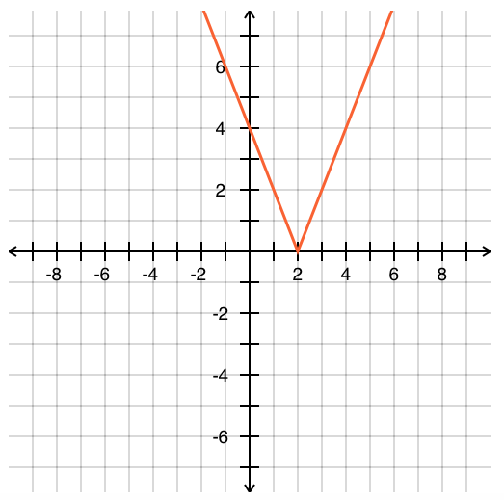

- Morgan can start wrestling at age 5 in Division 1. He remains in that division until his next odd birthday when he is required to move up to the next division level. Which graph correctly represents this information?

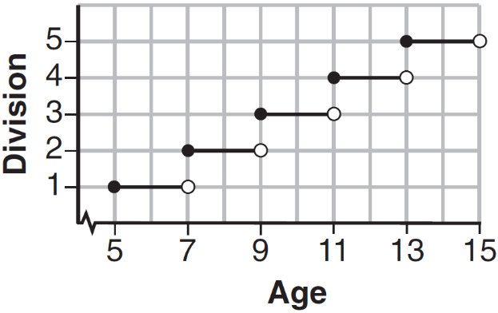 | 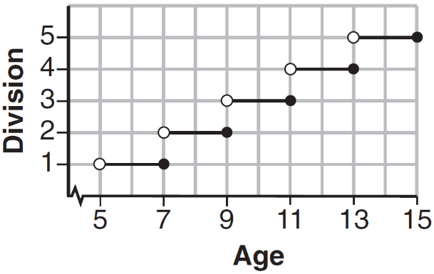
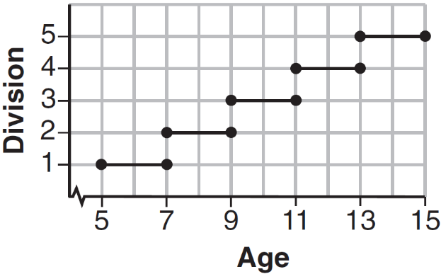 | 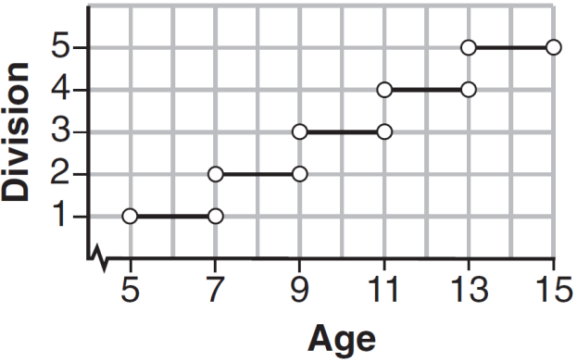

- Which function is represented by the graph below?

- $y=\left\{\begin{aligned}2 \text{if }x≥1 \\ 2 \text{if }x<-2\end{aligned}\right\}$  - $y=\left\{\begin{aligned}1 \text{if }x≥2 \\ -2 \text{if }x<2\end{aligned}\right\}$  - $y=\left\{\begin{aligned}1 \text{if }x≤2 \\ -2 \text{if }x>2\end{aligned}\right\}$  - $y=\left\{\begin{aligned}1 \text{if }x>2 \\ -2 \text{if }x≤2\end{aligned}\right\}$ | 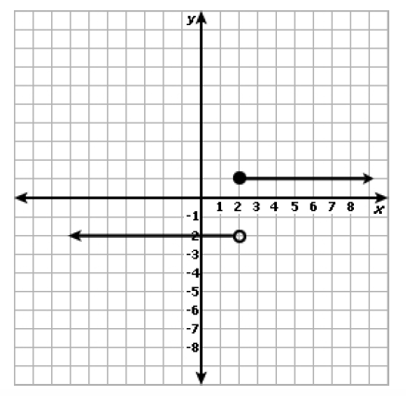

Extra Credit

- Match the graphs below with the appropriate function and give evidence to support your conclusion.

Graph A  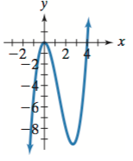 | Graph B  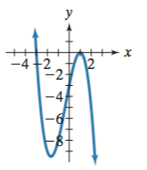

f(x) = -x³ – x² + 5x – 3

__________________________________________________________________________________________

__________________________________________________________________________________________

__________________________________________________________________________________________

g(x) = x³ – x²

__________________________________________________________________________________________

__________________________________________________________________________________________

__________________________________________________________________________________________

- In the graph below of y = 3x⁷ – 5x³ + x

How many extrema does the graph have?  - 3  - 4  - 5  - 6 | 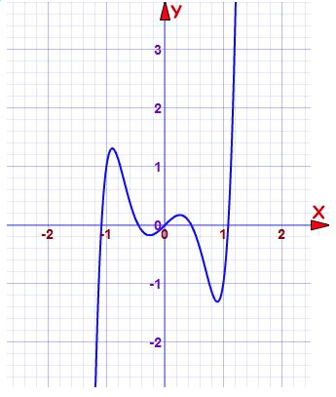

- The graph of a piece-wise function f(x) is shown below.

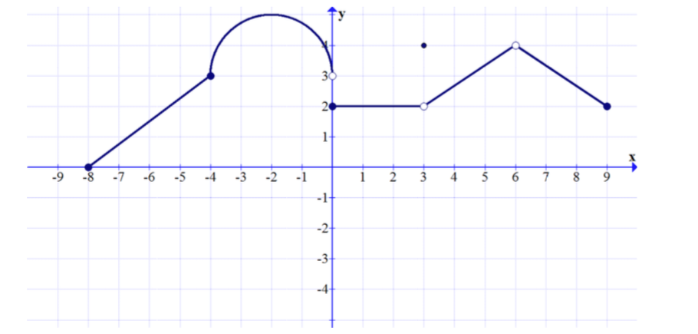

For which values of x is f(x) discontinuous across the interval -8 ≤ x ≤ 9?

- f(x) is discontinuous when x = -8, x = -4 and x = 9
- f(x) is discontinuous when x = -8, x = 3 and x = 4
- f(x) is discontinuous when x = 2, x = 3 and x = -4
- f(x) is discontinuous when x = 0, x = 3 and x = 6

Unit F3: Functions – Cubic, Piece-wise, Square Root and Cubic Root Functions
Score Sheet and Report

# | Answer |  | Subdomain Score | Subdomain
1 |  |  | /13 | Key features of cubic, piece-wise, square root, and cubic root functions.
2
3
4
5
6
7
8
9
10
11
12
13
14 |  |  | /7 | Graphing cubic, piece-wise, square root, and cubic root functions.
15
16
17
18
19
20
Extra Credit
21 |  | Constructed Response – Record Your Answer Below
 |  | /2
22 |  |  | +
23
Total |  |  | /20 %

