Systems of Equations Performance Task – Teacher Support

Common Core State Standards
- 8.EE.C.8 - Understand that solutions to a system of two linear equations in two variables correspond to points of intersection of their graphs, because points of intersection satisfy both equations simultaneously.
- HSA.REI.C.6 – Solve systems of linear equations exactly and approximately (e.g., with graphs), focusing on pairs of linear equations in two variables.

Core Skills Needed:
- Write linear equations
- Evaluate linear equations
- Solve linear equations
- Identify the solution to a system of linear equations
- Organize data in a table
- Construct a graph of a system of linear equations

Solutions:

- Tony - Tony could go to the gym 16-19 times in a month (4 times a week). Using 17 times in a month we find that he would have been better off choosing plan B.

Plan A: 4(17) + 10 = $78
Plan B: 2(17) + 30 = $68

Olivia – Assuming Olivia goes to the gym only 5 times in the month (she may go more) we find that she would have been better off with plan A.

Plan A: 4(5) + 10 = $30
Plan B: 2(5) + 30 = $40

Melissa – She knows she wants to spend $70. Solving both equations, or plans, for $70 we find that she would have been able to go to the gym 15 times under plan A and 20 times under plan B. So, she should choose plan B.

Darnell – Darnell could pick either plan. Both plans cost the same amount, or $50 if he goes to the gym 10 times.

- Table Graph

Workout Visits | Plan A | 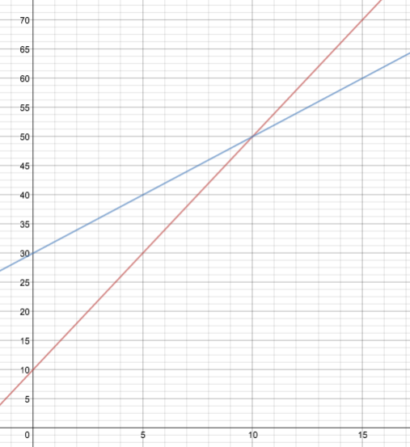  Plan B
1 | $14 | $32
2 | $18 | $34
3 | $22 | $36
4 | $26 | $38
5 | $30 | $40
6 | $34 | $42
7 | $38 | $44
8 | $42 | $46
9 | $46 | $48
10 | $50 | $50
11 | $54 | $52
12 | $58 | $54
13 | $62 | $56
14 | $66 | $58
15 | $70 | $60
16 | $74 | $62
17 | $78 | $64
18 | $82 | $66
19 | $86 | $68
20 | $90 | $70
21 | $94 | $72
22 | $98 | $74
23 | $102 | $76
24 | $106 | $78
25 | $110 | $80  Red – Plan A  Blue – Plan B
26 | $114 | $82
27 | $118 | $84
28 | $122 | $86
29 | $126 | $88
30 | $130 | $90
31 | $134 | $92

- The worker incorrectly placed the monthly charge next to the variable w. As a result, the person would be charged the monthly charge every time they workout instead of only getting charged that amount once. The correct way to write the functions would have been:

Plan A: A(w) = 4w + 10

Plan B: B(w) = 2w + 30

- Knowing that Olivia chose plan A, we will represent her with the expression 4a + 10. Since Tony chose plan B, we will use 2b + 30 for him.

Let a = # of times Olivia went to the gym under plan A
Let b = # of times Toney went to the gym under plan B

a + b = 25 since we know that they both went to the gym 25 times
4a + 10 + 2b + 30 = $120 since we know that they spent $120 altogether

Solving for both equations we find out that Olivia went to the gym 15 times and Tony went to the gym 10 times. So, the answer is 10, Olivia went to the gym 10 times.

Solutions to Systems of Equations TASC Level Problems

- A
- C
- 3
- B
- 49

Additional Systems of Equations Question

From: https://www.illustrativemathematics.org/content-standards/8/EE/C/8/tasks/934

A type of pasta is made of a blend of quinoa and corn. The pasta company is not disclosing the percentage of each ingredient in the blend but we know that the quinoa in the blend contains 16.2% protein, and the corn in the blend contains 3.5% protein. Overall, each 57 gram serving of pasta contains 4 grams of protein. How much quinoa and how much corn is in one serving of the pasta?

Math Performance Task: Systems of Equations
Fitness Planet

Directions: On separate paper and graph paper complete 3 of the 4 the following tasks.

Fitness Planet offers two monthly membership plans. Under plan A, a member can pay a monthly fee of $10 and $4 every time that member wants to work out, or a member can choose plan B, and pay a monthly fee of $30 and pay $2 every time they want to work out.

- You have a few friends that all want to join, but they don’t know which plan is best for them. Consider each person below. Explain to them which option is most likely to cost them the least while fitting into their fitness plan.

Tony: “I want to get really fit. I am going to go to the gym like 4 times a week. No, seriously, I mean it.”

Olivia: “I know I want to lose weight, but secretly, I hate working out (sigh). I know that I want to go at least once a week, because, um, I heard Tony is joining too.”

Melissa: “I have $70 to spend on going to the gym each month. Which option will allow me to go to the gym most often?”

Darnell: “I know I only have time to go to the gym about 10 times each month. Which plan will cost me the least?

- Fitness Planet has realized that people are having a hard time deciding which plan is best for them. Construct a table and graph that could help potential members visually compare the two plans.

- A worker at Fitness Planet says that the two functions below could be used to calculate the cost of joining Fitness Planet for a month given the number of times a member works out (w). But something seems wrong with the functions. Help the guy out by rewriting the functions for him and then explaining where he went wrong.

Plan A: A(w) = 10w + 4

Plan B: B(w) = 30w + 2

- Tony choose plan B and Olivia choose plan A. Together, they both went to the gym a total of 25 times last month costing them $120 altogether. How many times did Olivia go to the gym last month?

Systems of Equations TASC Level Problems

- The price of a pair of pants, P is $100 more than the price of a t-shirt, T. The total price for the pair of pants and t-shirts is $165. Which system of equations can be used to find each price?

- $\left\{\begin{aligned}P=T+100 \\ P+T=165\end{aligned}\right\}$
- $\left\{\begin{aligned}P=T-100 \\ P+T=165\end{aligned}\right\}$
- $\left\{\begin{aligned}P=T+100 \\ P-T=165\end{aligned}\right\}$
- $\left\{\begin{aligned}T=P+100 \\ P+T=165\end{aligned}\right\}$

- Which system of equations corresponds to this graph?

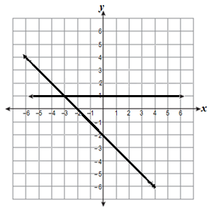

- Steve has 8 U.S. coins in his pocket. Half of the coins are quarters, none of them are pennies, and the value of all coins is $1.35. How many dimes does Steve have?

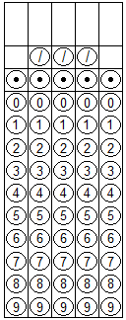

- What is the solution to the system of equations below?
2x + y = 19
x – y = 11

- x = 5 ; y = 9
- x = 10; y = -1
- x = 10; y = 1
- x = 30; y = 19
- Fred, F, can do 24 more pushups than Tye, T. Together they did a total of 74 pushups. How many pushups did Fred do?

