Name: _________________________________________________________ Date: ______________

TASC Math Practice Exam V3 – GHI & JKL Aligned

Part I – Calculator use allowed.

1. Given the equation ,

*x* =

1. 1
2. 7
3. 15
4. 64
5. Albert Einstein’s theory of relativity is where ** is energy, ** is mass and ** is the speed of light. State the equation in terms of mass.
6. 
7. 
8. 
9. 
10. Mario’s landlord charges a fee for every day that rent is late. The monthly cost in dollars, *C*, to rent the space with *d* days of late rental payment is modeled by the equation

.

This month Mario had to pay $875 for rent plus late rental payment. How many days late was Mario in paying his rent this month?

1. 5
2. 15
3. 75
4. 800

|  |  |
| --- | --- |
| 1. The surface area of a cube is 486 cm2. In cm, how long is each edge of the cube? |  |

1. Which of the following cities has the greatest population density?

|  |  |  |
| --- | --- | --- |
| **City** | **Population** | **Area (km2)** |
| Guttenberg, New Jersey | 11,481 | 0.507 |
| Colombo, Sri Lanka | 323,257 | 37 |
| Montreal, Canada | 1,649,519 | 365.13 |
| New York, New York | 8,175,133 | 783.73 |

1. Guttenberg, New Jersey
2. Colombo, Sri Lanka
3. Montreal, Canada
4. New York, NY

|  |  |
| --- | --- |
| 1. Consider the function:     What is the value of *a* if the zeros of this function are -4, and 4? |  |

1. A lawyer charges a one-time acceptance fee of $500 plus $200 per hour for each case that he represents.

What type of function should be used to model the fee the lawyer charges for each case he handles, and why should this type of function be used?

1. exponential growth; because the growth factor is a fixed percentage rate greater than 100%
2. exponential decay; because the growth factor is a fixed percentage rate less than 100%
3. linear decay; because the rate of change is constant and negative
4. linear growth; because the rate of change is constant and positive
5. Which type of number is the sum of  and ?
6. imaginary number
7. complex number
8. rational number
9. irrational number
10. The table below gives selected values for the linear function, .

|  |  |
| --- | --- |
| *x* |  |
| 12 | 18 |
| 13 | 20 |
| 14 | 22 |
| 15 | 24 |

Which of the following functions has the same slope as ?

1. 
2. 
3. 
4. 

|  |  |
| --- | --- |
| 1. What is the value of ? |  |

1. Which expression is equivalent to ?
2. 
3. 
4. 
5. 
6. Carol compares two functions  and .

The table lists the values of the functions for increasing values of.

|  |  |  |
| --- | --- | --- |
| *x* |  |  |
| 0 | 1 | 0 |
| 1 | 2 | 1 |
| 2 | 4 | 4 |
| 3 | 8 | 9 |

If the trend in the table continues, at what whole number value of  will the value of  exceed ?

1. 4
2. 5
3. 6
4. 7

|  |  |
| --- | --- |
| 1. A ladder is leaning against a building. The foot of the ladder is 16 feet from the base of the building, and reaches up to a window 30 feet high. How long is the ladder? |  |

1. . Oak has a density of about 0.711 grams per cubic centimeter. To the nearest gram, what is the mass of an oak cylinder with a radius of 6 cm and a height of 20 cm?
2. 169 grams
3. 483 grams
4. 1,607 grams
5. 3,180
6. Consider the polynomial expression.

Which of these are factors of the expression?

1. (*x* – 5)(*x* + 8)
2. (*x* + 5)(*x* – 8)
3. (*x* – 10)(*x* + 4)
4. (*x* + 10)(*x* – 4)

|  |  |
| --- | --- |
| 1. Consider the function .   What is the value of *y* when *x* = 2? |  |

1. An appliance store sells air conditioners with different BTU ratings, which tell how much heat the air conditioners can remove from the air in one hour. Suppose a customer has a room with a width of 20 feet, a length of 40 feet, and a ceiling height of 10 feet that has a cooling requirement of 2 BTUs per cubic foot.

What would be the best air conditioner BTU rating for the appliance store to recommend to the customer?

1. 4,000
2. 8,000
3. 16,000
4. 48,000
5. Solve for *x*: 
6. -6
7. -3
8. 3
9. 6
10. A scatter plot was constructed on the graph below and a line of best fit was drawn.

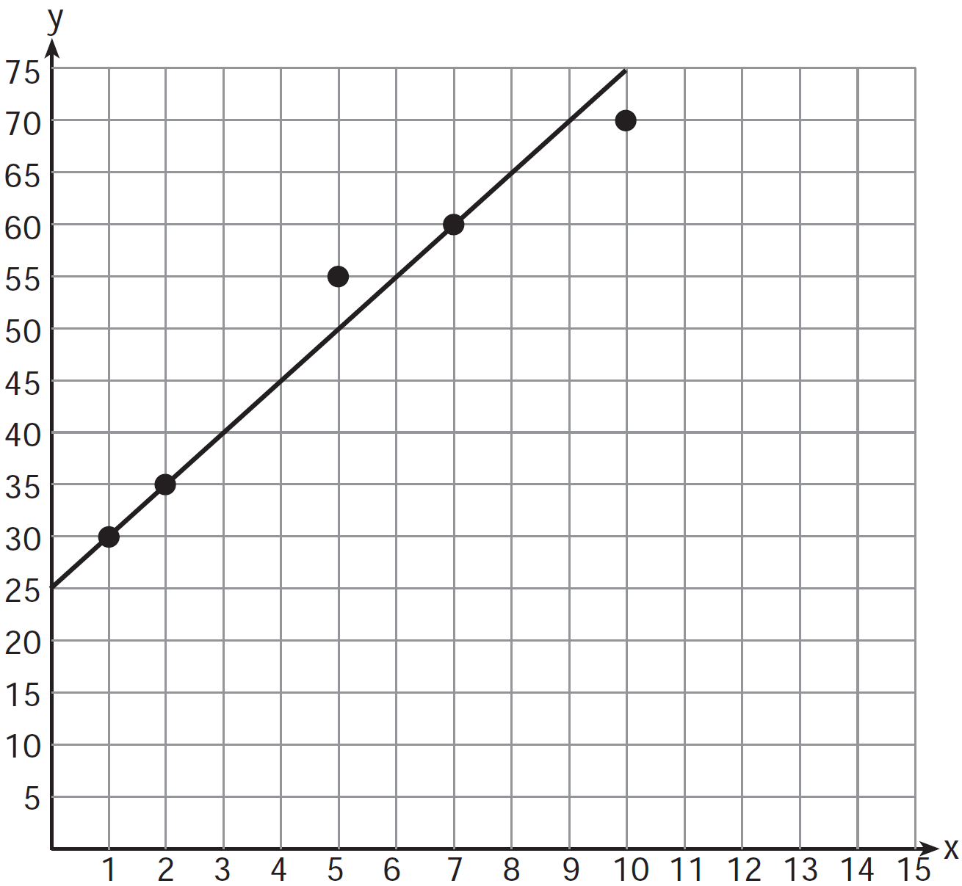

What is the equation of this line of best fit?

3. Which names the function for this arithmetic sequence?

8, 4, 0, −4, . . .

1. 
2. 
3. 
4. 

|  |  |
| --- | --- |
| 1. Find the volume of the figure below: |  |

1. The scatterplot below shows the test scores of students and the number of hours they spent on social media the night before a test.

|  |  |
| --- | --- |
|  | * The equation for the line of best fit is   *y* = -7.5*x* + 100   * *x* represents the number of hours the student spent on social media the previous night * *y* represents the test score |

What is the correct interpretation of the slope of the trend line?

1. On average, test scores increase 7.5 points for every hour spent on social media the night before a test.
2. On average, test scores decrease 7.5 points for every hour spent on social media the night before a test.
3. On average, test scores increase 100 points for every hour spent on social media the night before a test.
4. On average, test scores decrease 100 points for every hour spent on social media the night before a test.

|  |  |
| --- | --- |
| 1. Consider the cylinder shown with a diameter (*d*) that is inches (in.).   Which is the best estimate of the volume of the cylinder?   1. 95.4 in.3 2. 381.5 in.3 3. 84.8 in.3 4. 42.4 in.3 |  |

1. Which function matches the *x* and *y* values shown in the accompanying table of values?

|  |  |
| --- | --- |
| ***x*** | ***y*** |
| 4 | 7 |
| 6 | 8 |
| 8 | 9 |
| 10 | 10 |



|  |  |
| --- | --- |
| 1. Suppose Rectangle JKLM, shown at right, is translated to another location on the coordinate plane to form J’K’L’M’.   If three vertices of J’K’L’M’ are J’(-3, 5),  K’(1, 5), and L’(1, -1), which could be the coordinates of vertex M’?   1. (-6, 1) 2. (5, -3) 3. (1, 1) 4. (-3, -1) |  |

Name: _________________________________________________________ Date: ______________

TASC Math Practice Exam V3 – G, H, I Aligned

Part II – Calculator use NOT allowed.

1. Consider this system of equations.

2*x* – 5*y* = 11

-2*x* + 3*y* = -9

Which of the choices below represents the solution to the system above?

1. (-3, -1)
2. (-1, 3)
3. (3, -1)
4. (3, 1)
5. Look at the transformation below.

|  |  |
| --- | --- |
| Which rule describes the transformation shown?   1. Reflection across the  -axis 2. Reflection across 3. Rotation ° about the origin 4. Translation  units right |  |

1. What type of number is the sum of  and ? Why?
2. irrational; because the sum of two rational numbers is irrational
3. irrational; because the sum of two irrational numbers is irrational
4. rational; because the sum of two irrational numbers is rational
5. rational; because the sum of two rational numbers is rational
6. What is the definition of a circle?
7. the set of all points that are an equal distance from a point
8. the set of all lines that are an equal distance from a point
9. the set of all points that are an equal distance from a line
10. the set of all lines that are an equal distance from a line
11. What is equivalent write?

A. 

B. 

C. 

D. 

|  |  |
| --- | --- |
| 1. An employee earns $12.50 per hour. On Monday, she works from 11:00 a.m. until 4:30 p.m., and she takes a 30 minute unpaid lunch break. How much does the employee earn on Monday? |  |

|  |  |
| --- | --- |
| 1. A jar contains 4 blue jellybeans and 3 green jellybeans. Kim reaches into the jar, grabs a green jellybean and eats it. Kim then reaches back into the jar and pulls out a second jellybean. What is the probability, expressed as a fraction, that Kim selected a green jellybean again? |  |

1. Which task is not a component of an observational study?
2. The researcher decides who will make up the sample.
3. The researcher analyzes the data received from the sample.
4. The researcher gathers data from the sample, using surveys or taking measurements.
5. The researcher divides the sample into two groups, with one group acting as a control group.
6. The population of a certain strain of virus can be modeled by the function, where  is the population and  is the time in weeks.

What is the percent change in the population of the virus and does this represent exponential growth or decay?

1. 15% exponential decay
2. 15% exponential growth
3. 115% exponential decay
4. 115% exponential growth
5. For what value of *x* is  not a real number?

A. 2

B. 5

C. −2

D. −5

|  |  |
| --- | --- |
| 1. Solve for *x*:   5*x* – 4 = 3*x* + 10 |  |

1. A manager is determining the number of hours to assign to part-time employees, *n*, and full-time

employees, *s*. These are the conditions the manager must follow:

|  |
| --- |
| The budget allows for only 500 total hours.  Part-time employees are to work less than half of the total hours of full-time employees. |

Which system of inequalities can the manager use to determine the number of hours to assign to each type of employee?

1. 



1. 



1. 



1. 



1. Which ordered pair is in the solution set of the system of linear inequalities graphed below?

|  |  |
| --- | --- |
| 1. (3, 1) 2. (4, 1) 3. (5, 2) 4. (3, 3) |  |

1. The following are heights of the members of each crew in a certain station.

Crew 1: 64, 70, 72, 66, 65, 67, 67

Crew 2: 65, 72, 71, 69, 64, 64

Which crew has the greater median height?

1. Crew 1 and Crew 2 have the same median height.
2. Crew 1
3. Crew 2
4. The answer cannot be determined.
5. One gallon of paint covers 350 square feet of wall space. How many whole gallons should you buy to cover 1,500 square feet of wall space?
6. 3
7. 4
8. 5
9. 6
10. This boxplot shows the sales of water heaters over one year at Hefty Water and Heating.

2013 Water Heater Sales

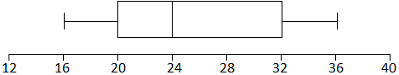

What is the upper quartile number of water heaters sold in 2013?

A. 20

B. 24

C. 32

D. 36

1. Which graph represents the function?

|  |  |  |  |
| --- | --- | --- | --- |
| A. |  | C. |  |
|  |  |  |  |
| B. |  | D. |  |

1. The cost of riding in a taxi-cab in Center City can be modeled by the linear equation *y* = $3*x* + $2.75 where *x* represents the number of miles travelled in the taxi and *y* represents the total cost of the taxi ride. Which interpretation of this linear model is correct?
2. The taximeter starts at $2.75 and goes up $3.00 for each mile that is driven.
3. The taximeter starts at $3.00 and goes up $2.75 for each mile that is driven.
4. The taximeter starts at $0.00 and goes up $3.00 for each mile that is driven.
5. The taximeter starts at $0.00 and goes up $5.75 for each mile that is driven.
6. Consider this inequality.



Which of these shaded half-planes represents the solution region of the inequality?

|  |  |  |  |
| --- | --- | --- | --- |
| A. |  | C. |  |
|  |  |  |  |
| B. |  | D. |  |

1. What is equivalent to (*x* – 6)2?
2. 2*x* – 12
3. *x*2 – 12
4. *x*2 – 12*x* + 36
5. *x*2 – 36
6. The graph shows the growth of a plant.

|  |  |
| --- | --- |
| How many days did it take for the plant to grow to triple its initial height? |  |

1. Jean, J, worked 3 hours longer this week than Alice, A. They worked a total of 32 hours. Which system of equations can be used to find how long each worked?

A. J + 3 = A

J − A = 32

B. J + 3 = A

J + A = 32

C. A + 3 = J

J + A = 32

D. A + 3 = J

J − A = 32

1. The set below shows a relation between some values of *x* and *y*.

{(-3, 4), (5, 2), (-8, 1), (6, 7), (*a*, 0)}

Select **two** possible values for *a* so that the relation is a function.

A. -3

B. 4

C. 5

D. 1

E. 6

F. -8

For questions #49 and #50, refer to the diagram below.

The side lengths of a trapezoid are marked as shown in the diagram.

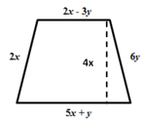

1. Using the fewest number of terms (simplest form), write an expression to represent the perimeter of the trapezoid above.

|  |
| --- |
|  |

1. The area of a trapezoid is , where area, ,  base one, and  base two.

Using the fewest number of terms (simplest form), write an expression to represent the area of the trapezoid above.

|  |
| --- |
|  |

Name ________________________ Date __________________

TASC Math Practice Exam (V3)

|  |  |  |  |
| --- | --- | --- | --- |
| Part 1 | | Part 2 | |
| # | Answer | # | Answer |
| 1 |  | 26 |  |
| 2 |  | 27 |  |
| 3 |  | 28 |  |
| 4 |  | 29 |  |
| 5 |  | 30 |  |
| 6 |  | 31 |  |
| 7 |  | 32 |  |
| 8 |  | 33 |  |
| 9 |  | 34 |  |
| 10 |  | 35 |  |
| 11 |  | 36 |  |
| 12 |  | 37 |  |
| 13 |  | 38 |  |
| 14 |  | 39 |  |
| 15 |  | 40 |  |
| 16 |  | 41 |  |
| 17 |  | 42 |  |
| 18 |  | 43 |  |
| 19 |  | 44 |  |
| 20 |  | 45 |  |
| 21 |  | 46 |  |
| 22 |  | 47 |  |
| 23 |  | 48 |  |
| 24 |  | 49 |  |
| 25 |  | 50 |  |